**Everybody Eats - MSiA Team Summaries**

*Mengyang (Doris) Cao, Aditya “Adi” Tyagi, Xiaohan (Aria) Wang*

# **Abstract**

This project was conducted to bring insights into food insecurity in the City of Evanston and to facilitate the decision making process for the task force. With the help of data and analytics tools, we aimed to help the public and the city to better understand the food insecurity in Evanston, and we hope to set an example of how to use data analytics for organizations in Evanston and other cities.

# **1 Introduction**

The COVID-19 pandemic has led to a drastic increase in food insecurity. The national food insecurity rate in April 2020 was predicted to be 10.1% following the historical trend; however, the actual food insecurity rate in April 2020 was 22.8% according to the COVID Impact Survey (Schanzenbach and Pitts, 2020). The food insecurity situation is even more severe for the vulnerable populations. According to Schanzenbach and Pitts (2020), food insecurity rates in the U.S. tripled in April 2020 for families with children, as compared to the level in March 2020.

Thanks to Professor Karen Smilowitz, Professor of Industrial Engineering and Management Science at Northwestern University, we were introduced to this project led by Maura Shea, former VP of Innovation at Feeding America. We collaborated with the food security task force at the City of Evanston on this project, aiming to build community food resilience in Evanston.

With the public data that we collected online and the data that the city and organizations provided, we conducted data analysis, created a collective impact toolkit and provided recommendations on future data collection and management. Through this project, we hope to help the city and the task force to better understand the needs of our food insecure neighbors and make more informed decisions in distributing charitable food.

# **2 Technical Approach**

With the help of our partners, we collected a number of different datasets from various sources. Below are the data that we used in our project:

1. 2020 Food insecurity rates by census tracts and ZIP Codes in Cook County from Feeding America (2018)
2. Food capacity breakdown and information about distributions for the food providers in Evanston
3. Measures of food access by census tracts in Evanston from USDA Food Access Research Atlas (Economic Research Service, 2015)
4. Free & Reduced Lunch program eligibility for schools in Evanston from Illinois State Board of Education (2020)
5. Various demographic and geographical data by census tracts in Evanston from PolicyMap
6. The monthly number of individuals/households receiving SNAP benefits by ZIP Codes in Cook County from the Greater Chicago Food Depository (July 2018 - June 2020)
7. Data about each Producemobile distribution (2016-2018)
8. COVID Impact Survey data for ChicagoNaperville-Elgin, Illinois-Indiana-Wisconsin (Wozniak et al., 2020)

Using these data, we did analysis on food insecurity rates both in Cook County and in Evanston, and we created prototypes for an interactive map, a Chatbot tool and a prediction model for food distributions, which the city can leverage in the future.

## **2.1 Data analysis**

In carrying out the data analysis, our basic philosophy was “**not to predict, but to infer**.” We sought to understand the factors affecting food insecurity in our community, rather than use them to predict food insecurity outright. This informed our choice of model & approach, in favor of simple and highly interpretable models.

Second, our guiding rationale behind modelling food insecurity in Evanston was to break down factors into two types:

* Structural Factors: Structural factors are those that are always present, and are a function of Evanston's history before the pandemic started.
* COVID-19 Impact Factors: COVID-19 Impact factors are those that have now come into the fore after the advent of the pandemic into the Evanston community.

The rationale behind following this two-tier approach is that it gives decision makers a well-laid out framework to understand food insecurity in their communities.

To understand structural factors, we limited our time scope to 2014-2018 data and built:

* Cook County ZIP Code model
* Evanston Census Tract model
* Evanston Census Tract Hypothesis Testing

To understand the COVID-19 impact factors, we analyzed data from 2018 to August 2020:

* SNAP Benefit Distribution in Cook County at ZIP Code Level
* ProduceMobile Food Distribution at Evanston location
* COVID-19 Impact Model

### **2.1.1 Inference of structural food insecurity**

The goal of digging into the structural food insecurity is to identify the underlying influential geographical or demographic factors that may explain the variation in food insecurity for different locations. With Feeding America’s data about the food insecurity population size for each geographical location in 2018, we applied predictive models (multivariate linear regression and Random Forest) on both the ZIP Code level in Cook County and the Census Tract level in Evanston, so that we could get a complete view of the food insecurity situation in Cook County and at the same time find out the factors that differentiate Evanston from other cities in the county. We also ran independent hypothesis tests (two-sample unpaired t-test) comparing the most food insecure zones and the least food insecure zones of Evanston to identify risk factors.

1. **Random Forest model on food insecurity population size by ZIP Code in Cook county**

The key factors according to the Random Forest model are median household income, the percentage of families in poverty, life expectancy, the number of households receiving SNAP benefits, percentage of households with any type of computer and # of households without a vehicle.

As is shown in the plots below, lower median household income or higher percentage of families in poverty corresponds to a larger food insecurity in the ZIP Code area. These 2 variables can both be taken as indicators of the economic condition for the location. As the model results show, wealthier neighborhoods have relatively less severe issues of food insecurity.

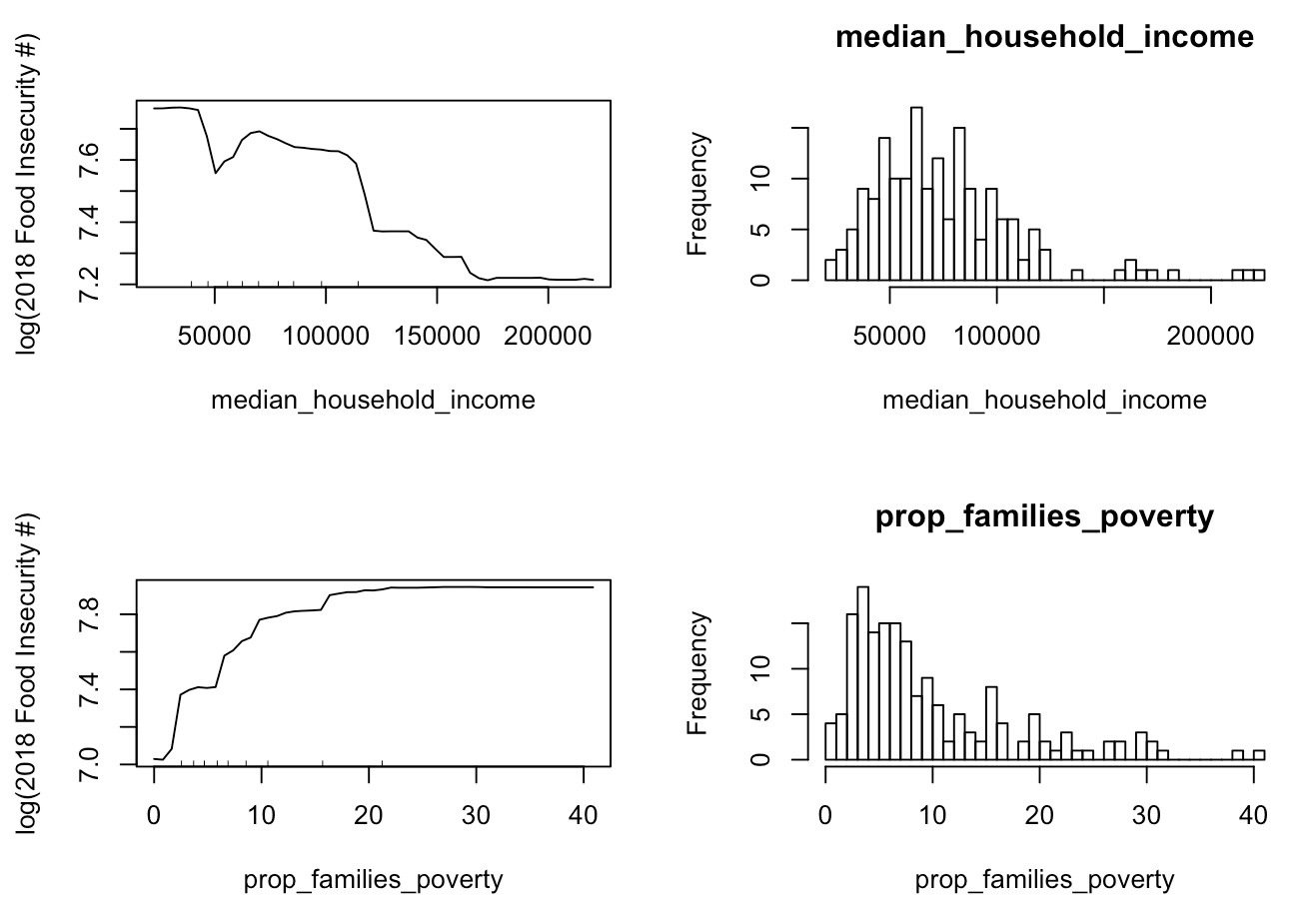

According to the model, areas with life expectancy around 70 tend to have a larger food insecure community than any other areas. For ZIP Codes with life expectancy larger than 70, a higher number that people expect to live in the location corresponds to a smaller food insecure population.

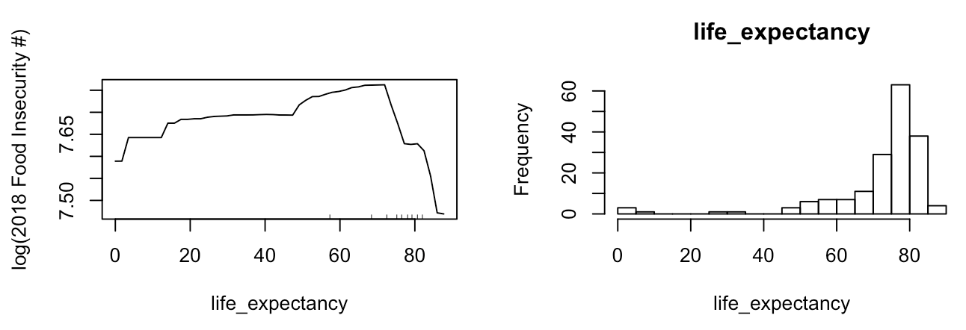

The ZIP Codes where more households have access to computers and a vehicle have relatively less people in food insecurity. These 2 factors can be interpreted as people’s access to food. Households with vehicles are able to access grocery stores that are farther from them, and therefore they have more choices of where and how to get food. Households with computers have more access to information and opportunities. If they are food insecure or at the risk of being food insecure, households with computers are able to learn about the support provided by the local organizations, and thus it is easier for them to get out of the food insecure condition.



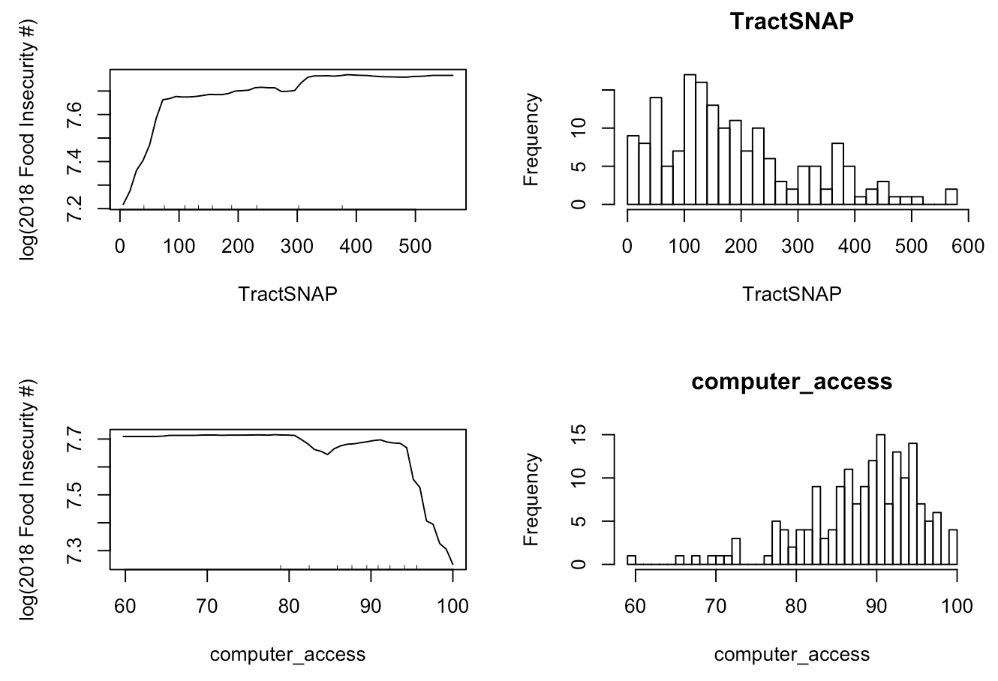

1. **Multivariate linear regression model on food insecurity population size by Census Tract in Evanston**

To understand the factors affecting food insecurity in Evanston in a simple and intuitive way, we built a multiple regression model. Each observation represented a census tract in Evanston. The dependent variable was the number of food insecure persons for each census tract in 2018. Factors covered included demographics, property values, etc. from the pre-pandemic era. The final dataset was formed by joining the PolicyMap dataset and the Feeding America food insecurity data on census tract. Mean/Median value imputation was carried out to address missing values. The following key factors were uncovered:

Tracts with larger numbers of food insecure persons have:

* **A younger median age**
* **A higher level of social vulnerability**
  + The CDC Social Vulnerability Index measures a community’s resilience (at the census tract level) when confronted by external stresses on human health, stresses such as natural or human-caused disasters, or disease outbreaks.
* **A lower level of racial segregation**
  + The Thiel Racial Segregation Index measures a community’s level of racial segregation. Higher Index values imply higher levels of racial segregation.

For further details, the following variables feed into the CDC Social Vulnerability Index:

* Below poverty
* Unemployed
* Income
* No High School Diploma
* Aged 65 or Older
* Aged 17 or Younger
* Civilian with a Disability
* Single-Parent Households
* Minority
* Speaks English “Less than Well”
* Multi-Unit Structures
* Mobile Homes
* Crowding
* No Vehicle
* Group Quarters

The illustration below shows the 15 component factors of the Social Vulnerability Index grouped into 4 themes:

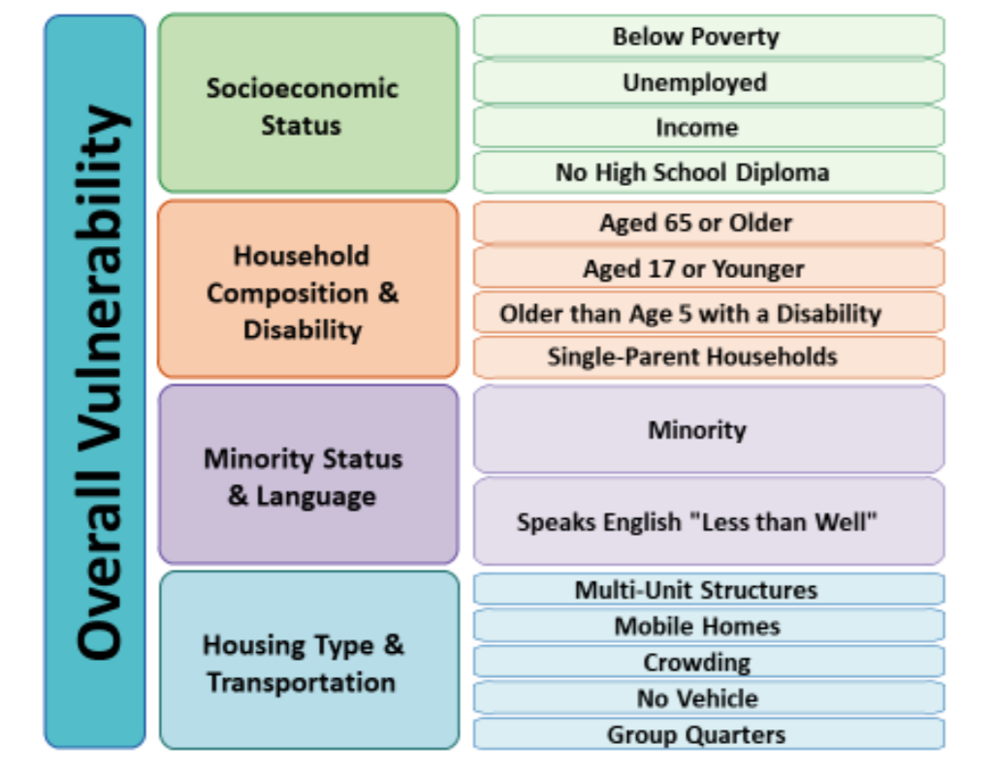

#### **Two-sample unpaired t-test on the most vs. least food secure tracts in Evanston**

To provide another perspective on food insecurity at the census tract level in Evanston, we decided to apply a hypothesis testing approach. We compared the top 5 food secure tracts with the bottom 5 least food secure tracts in Evanston across a range of factors.

We used a two-sample (unpaired) t-test since the population standard deviation was unknown. Most of the data came from PolicyMaps between 2014 and 2018. For all hypotheses, we used a significance level of 10%; however, for a few hypotheses, we used a significance level of 15%.

Compared to high food security tracts, low food security tracts in Evanston have/are:

* a lower household income
* a lower age
* more socially vulnerable
* lower median home loan amount
* lower median home value
* more nonwhite in general
* greater non-English speaking proportion
* higher hispanic population
* less racial segregated
* lower proportions of people with bachelor’s degrees
* lower computer access
* lower average travel times to work

However, high food security and food low food security tracts in Evanston are similar when it comes to:

* proportion of families in poverty.
* number of jobs
* number of housing units
* life expectancy
* proportion of students in public school
* median leverage ratios
* proportion of disabled people
* average household size
* proportion of men

### **2.1.2 Impact of COVID-19 on food insecurity**

Besides learning about the underlying factors to long-term food insecurity, we also hope to capture the short-term impact of COVID-19 on food insecurity. There was some difficulty for us to collect the data related to COVID-19’s impact. Our desired dataset should be updated on a regular basis and at a granular geographical level, whereas most public and reliable sources have data that either are collected only once every year or capture the food insecurity for the entire Cook County as a whole. However, thanks to the Greater Chicago Food Depository and Producemobile, we in the end got access to the monthly data about individuals/households receiving SNAP benefits by ZIP Codes in Cook County and the data about each Producemobile distribution. By analysing the time trend in these data, we hoped to get an idea of the food insecurity situation during the COVID-19 pandemic. In order to understand the population in food insecurity under the pandemic, we also did predictive modeling (multivariate logistic regression models) using the data from the COVID Impact Survey。

#### **The population receiving SNAP benefits by ZIP Code in Cook County over time**

As is shown in the line plots below, there are similar trends in the average number of households/individuals receiving SNAP benefits and the average allocated funding in all ZIP Codes in Cook County. They all have a very large increase since April 2020. The average number of people and the average allocated funding across ZIP Codes in Cook County have reached their highest levels since 2018, and the shape of the increases is almost like a hockey stick.

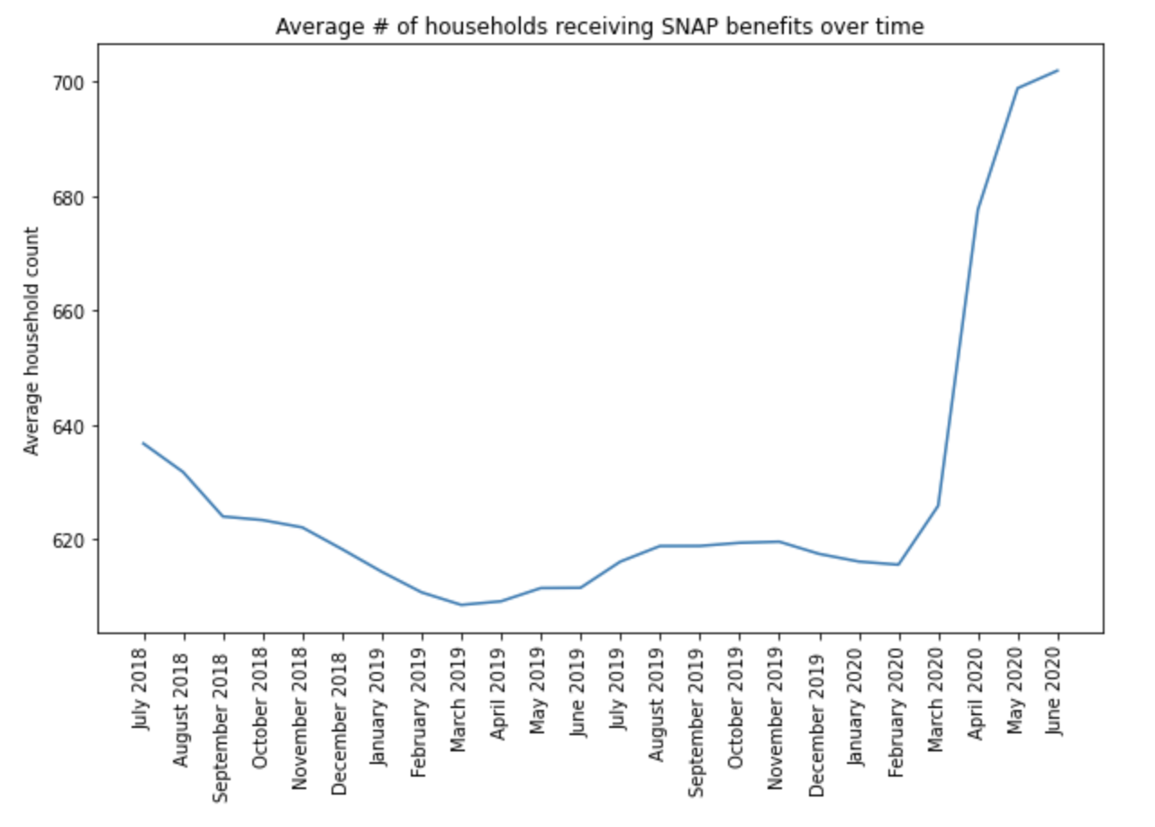

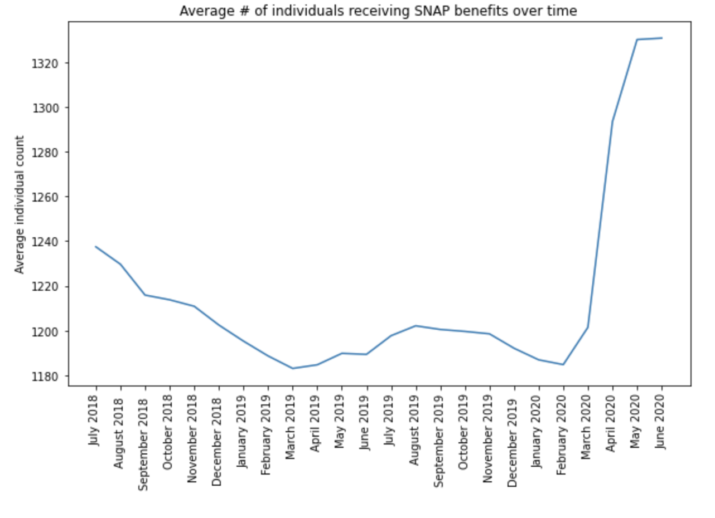

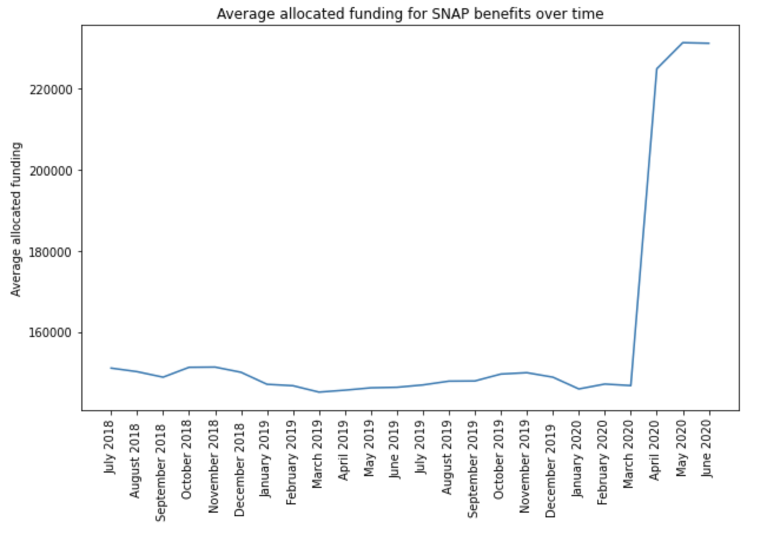

The trend also shows up in Evanston ZIP codes for the number of households/individuals receiving SNAP and the allocated funding. This indicates that COVID-19 has led to more people/households receiving SNAP benefits and more people facing food insecurity.

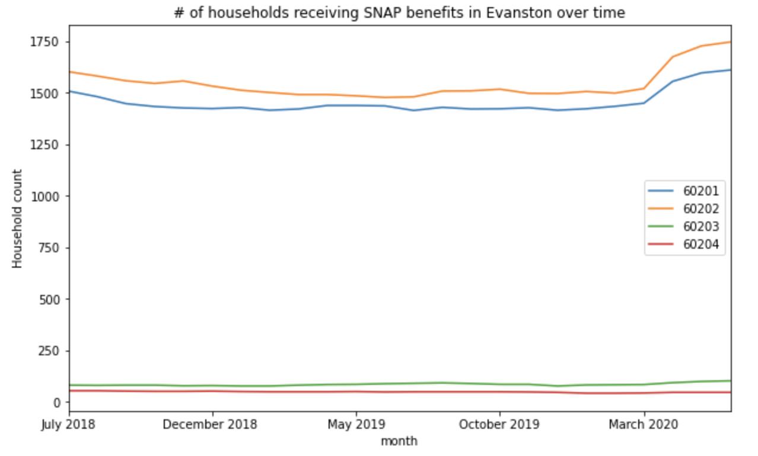

Compared with the level in March 2020, the number of individuals receiving SNAP in April this year increased by 7.0% on average across ZIP Codes in Cook County. As for the ZIP Codes in Evanston, the highest increase rate is 13.38% in 60203, and the lowest increase rate is 5.26% in 60204.

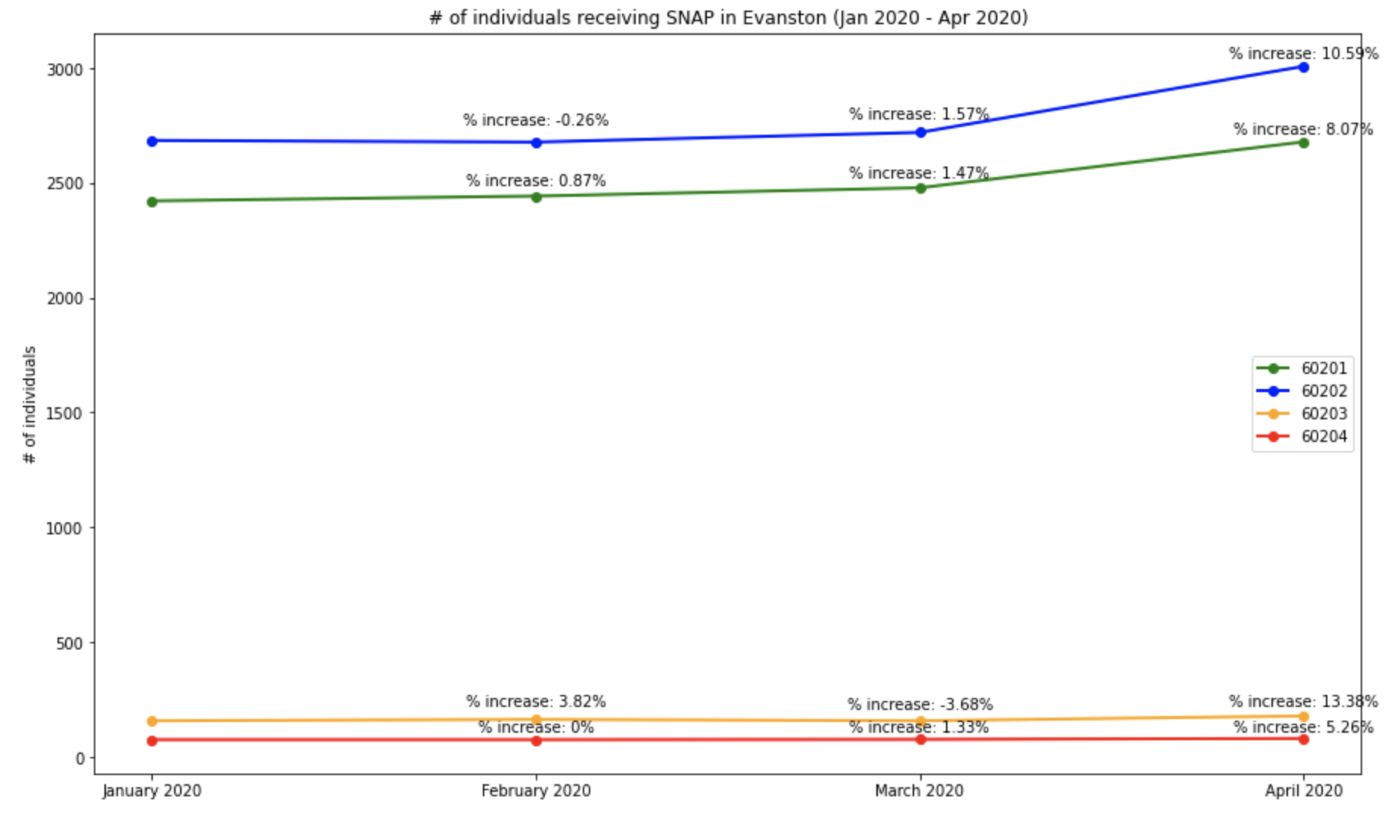

The data shows that there is a large increase in the number of people in need of SNAP due to the pandemic, and there should be potentially even more people having or at the risk of having food insecurity, since SNAP does not support families to the full extent. There is a gap between the households who are food insecure or at risk of food insecurity and the households who actually received SNAP benefits. Meanwhile, among the people supported by SNAP, there is a gap between their entire households’ food purchasing needs and the actual amount they receive from SNAP. Unfortunately, there is currently no data about how wide the gaps are and whether they got wider or narrower due to COVID-19, and further work is needed here.

#### **The population served by Producemobile distributions over time**

According to the data provided by Producemobile, there is a drastic increase in the number of participants at distributions in April and June this year. Producemobile used to have 1 distribution every month before the pandemic (except for March 2019 - September 2019), but since April 2020, the organizations started to distribute food to people in need twice per month in response to COVID-19. Before April 2020, except for the period between March and September last year, the number of guests signed in at the distribution every month was relatively stable between 200 and 300. Due to COVID-19, the increase in the unemployment rate has led to more people turning to Producemobile distributions for support.

Similar to the gap of needs unfulfilled by the SNAP program, distributions by food providers like Producemobile could not serve all the needs of the entire food insecure population. Further studies are necessary for us to truly understand the actual needs of our food insecure neighbors. However, the data allows us to take a peek into the situation.

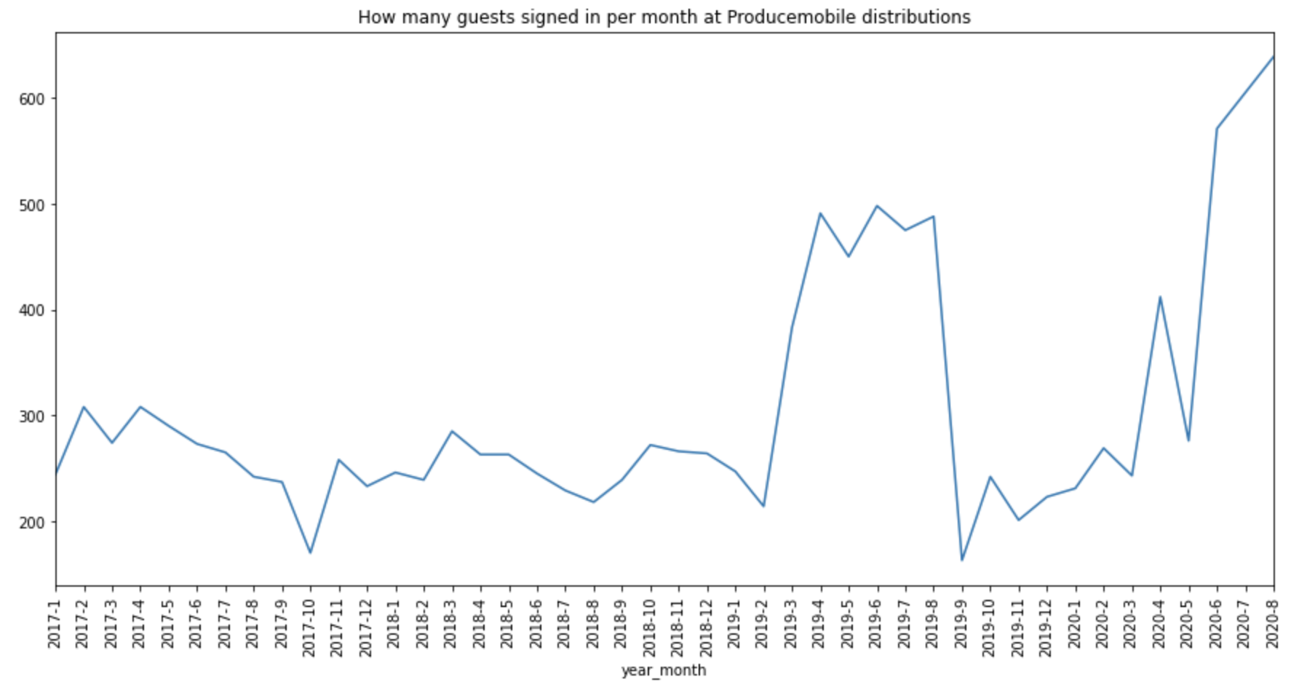

#### **COVID-19 Impact Model on Food Insecurity**

To get an idea of the risk factors in the arising of the food insecurity during this volatile COVID-19 environment, we used the latest data from the COVID-19 Impact Survey. This survey is conducted nationally once a week for three weeks three times during the height of the pandemic in the United States. The survey is managed by the NORC at the University of Chicago, and it is sponsored by the Data Foundation. The NORC also produces representative samples for various metropolitan areas in the United States, one of which is the Chicago MSA (metropolitan statistical area). The Chicago MSA includes participants in the area informally known as Chicagoland, and includes Evanston within its boundaries. In the survey, various questions were asked pertaining to economics, social life, physical health, healthcare situation, demographics, and food insecurity. Though we recognized that the dynamics of food insecurity may be different from Chicago compared to Evanston, this is the best attempt we have in order to understand the rapidly changing risk factors during the pandemic.

Our basic approach aims to infer the relevant risk factors and their effect on food insecurity. The tool we use to do that is a logistic regression model, postulated on the probability of a “food insecure response” from a survey participant. To build the model, we used a backward feature elimination process. The following risk factors associated with food insecurity were identified:

Conclusive Risk Factors:

* Not applying/receiving Supplemental Social Security in the past 7 days
* Not being covered by a health insurance from your employer/union
* Not being covered by Medicaid, Medical Assistance/other form of government assistance plans for low-incomes/disability
* Not being covered by any health insurance plan at all
* Being elderly (age bracket 65-74+)
* Being Black (non-hispanic), Hispanic, an other Non Hispanic,
* Being Hispanic
* An annual household income of between $10,000 to $20,000 (i.e. low household income)
* Having children in the household aged 6-12

Risk Factors where the researchers suspect a strong presence of lurking/confounding variables:

* Those who communicate electronically with friends/family a few times a week have a lower risk of food insecurity as compared to those who communicate with friends/families everyday **(lurking variable: unemployment)**
* More number of hours worked per week prior to COVID-19 start **(lurking variable: working many jobs)**
* Increased expectation of being employed 30 days from now **(implicit: present unemployment)**
* Increased expectation of being employed 3 months from now **(implicit: present unemployment)**

## **2.2 Interactive map**

To make food assistance information more visible and better serve the needs of food insecurity people, food providers and the City of Evanston, an interactive map with multiple layers has been created in Kepler.gl. From the map, neighbors in need and service providers can know:

* What food services are available and where’
* What additional capacity a provider might have
* Where there are gaps in service compared to level of need and what additional investments might be needed.

Data being used for map toolkit is mainly generated from the Evanston Food Resources, Meals Capacity Breakdown and Free Reduced Lunch files.

There are three layers in the current map (Map can be expanded to include additional functionality if necessary):

* The first layer shows distribution of food providers in Evanston.
  + Each dot on the map represents a provider, while color or the dot and color of outline of the dot represent the number of meals that are currently being provided at each location per week and maximum capacity of meals respectively. This helps to identify which provider has relatively higher/lower resources used and could potentially provide more if needed.
  + On clicking the dot, an information box with more detailed information (provider’s contact info, food providing type, food providing frequency, etc.) about each provider will pop up.
  + Another functionality in this layer is “Geocoder.” After a user type an address into the search box at the top right corner, a red icon will appear on the map which represents the location of the user. This functionality is added for the user to easily get a sense of relative distance between his/her location to a food provider, and support the user to make better informed decisions when choosing the provider that best serves his/her needs.

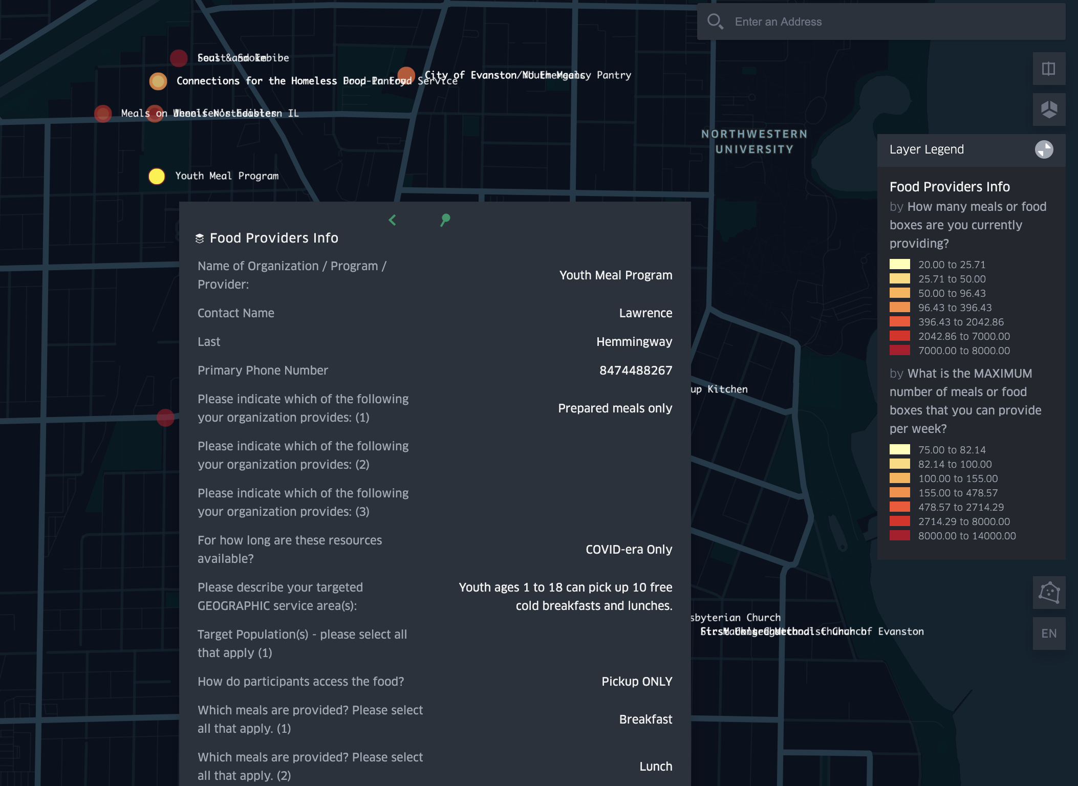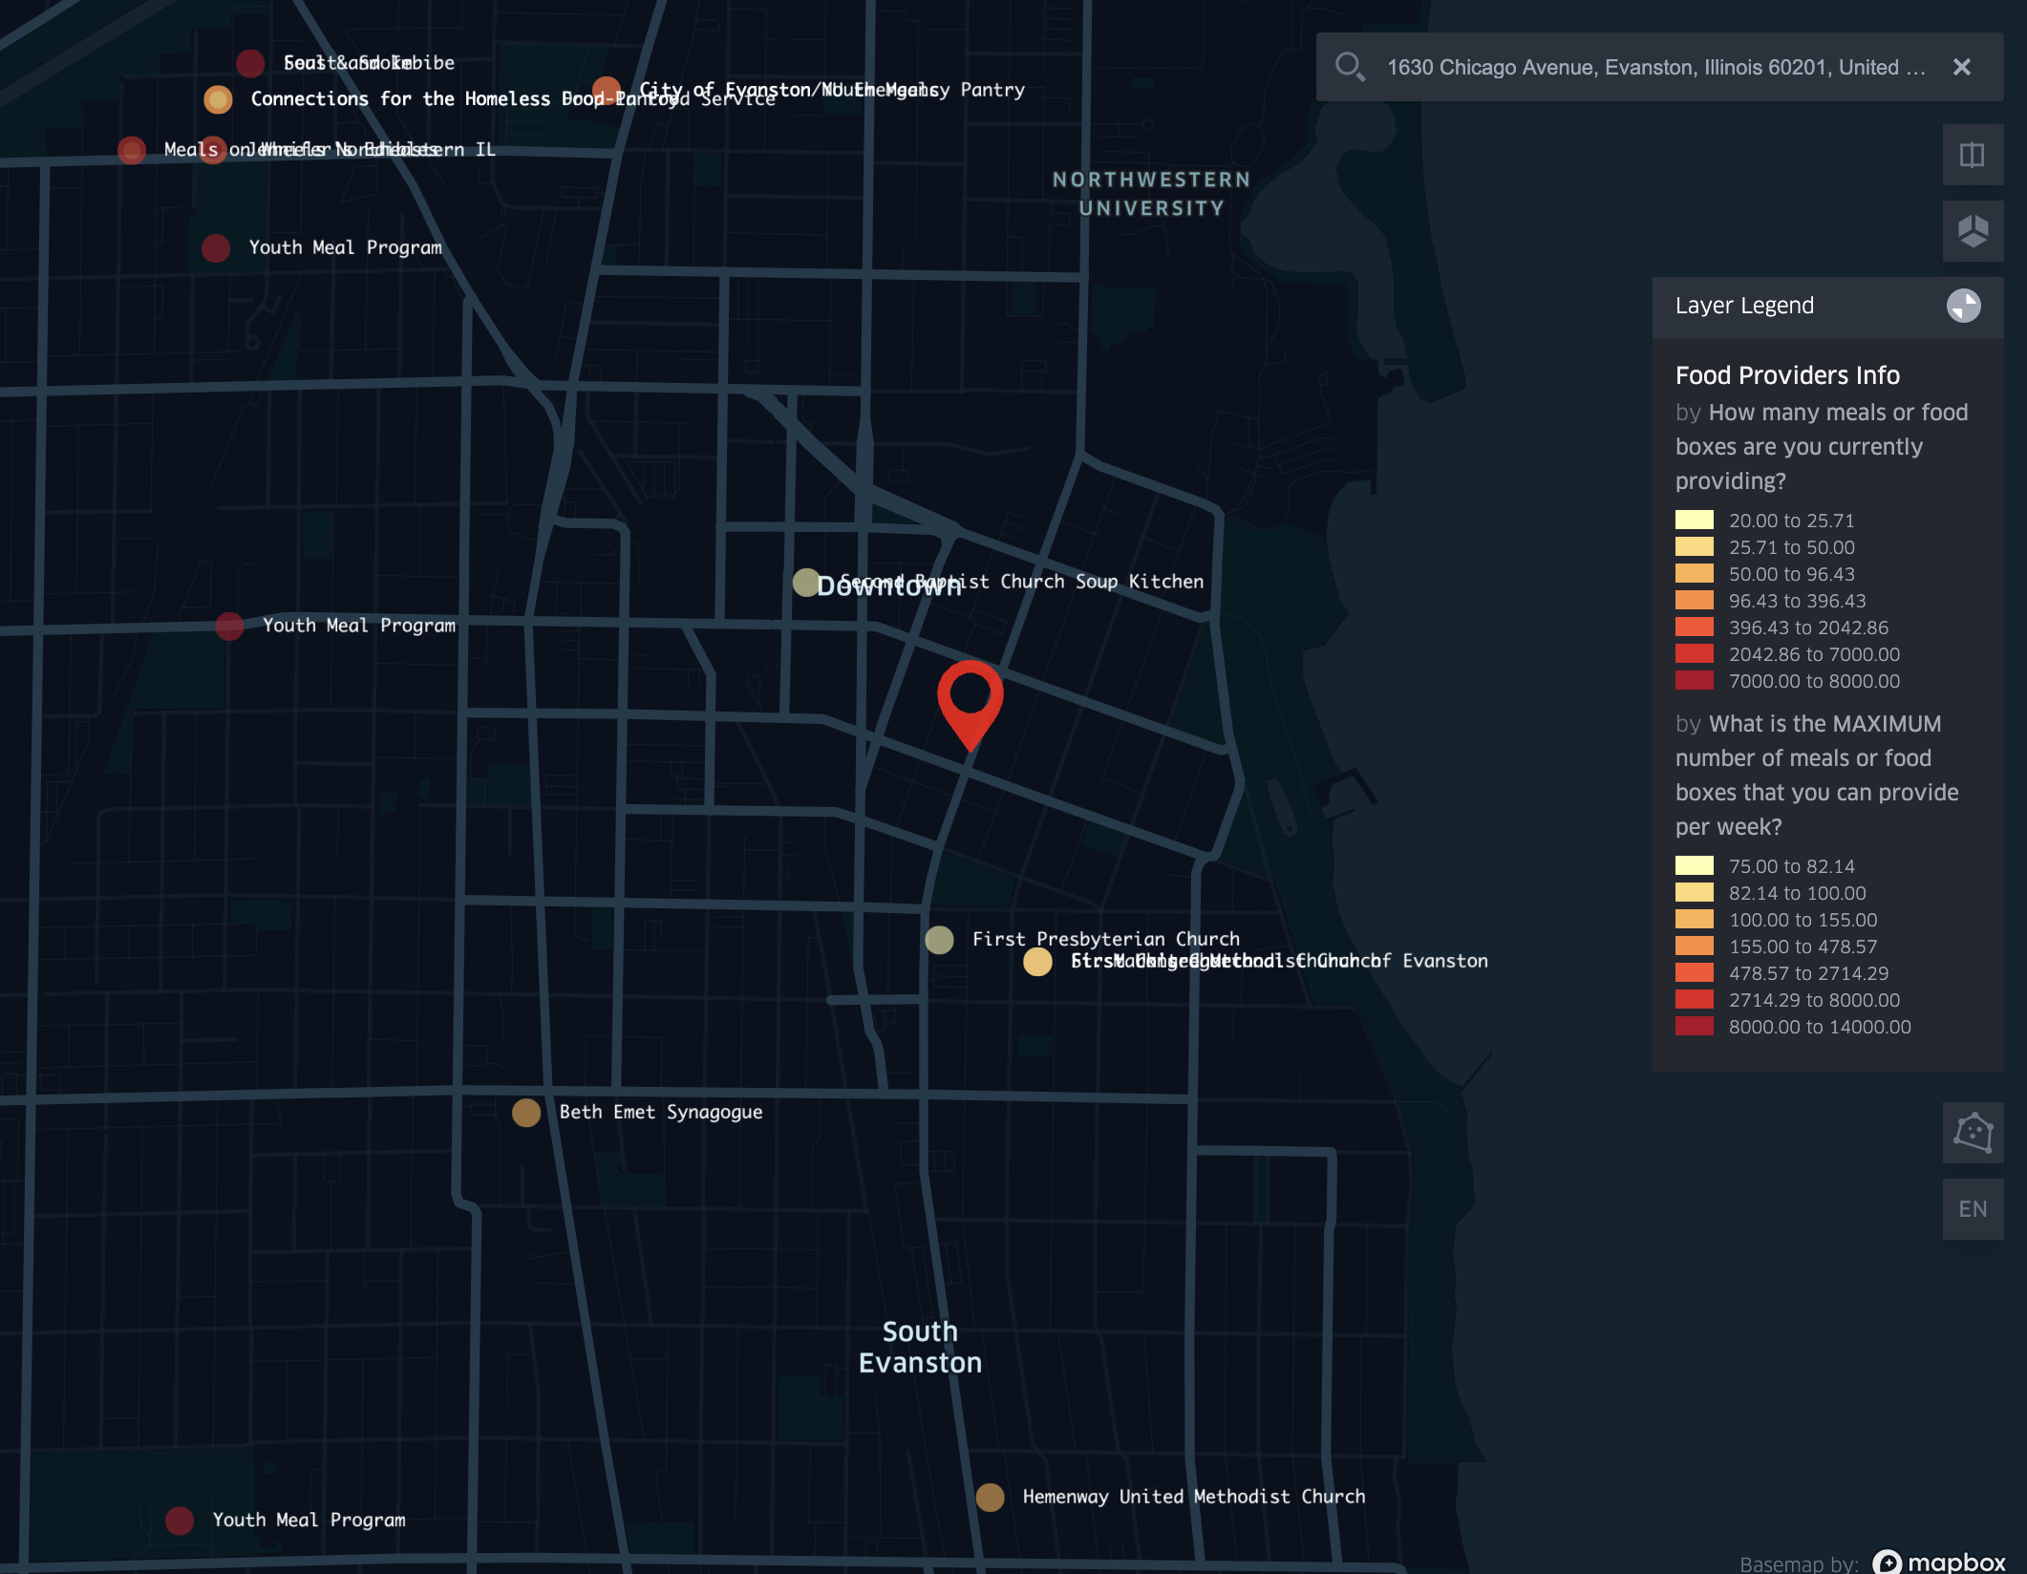

* The second layer shows existing connections among providers. Each dot on the plot represents the location of a provider. If two dots are connected by a line, then it indicates that those two providers are currently connected.

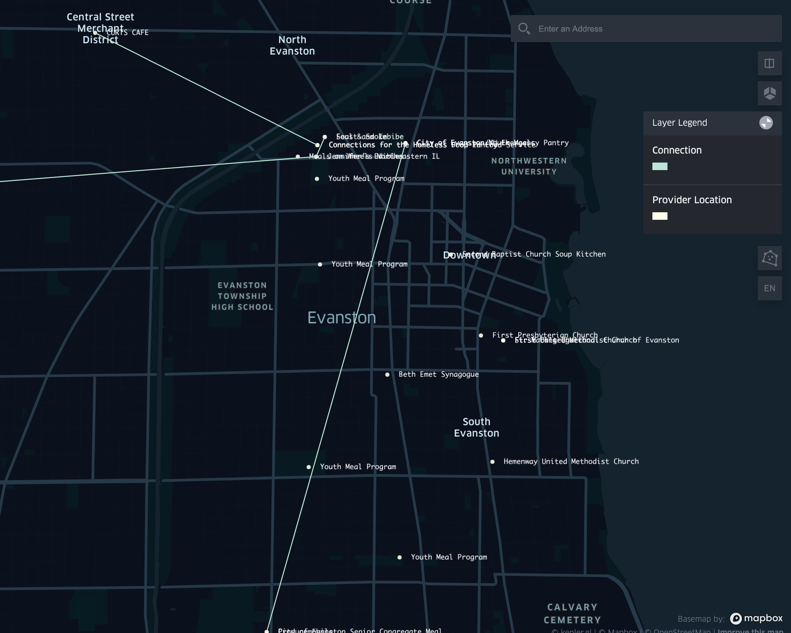

* The third layer shows the Free & Reduced Lunch (FRL) eligibility rate in each school district (D65) in Evanston. The goal is to use free reduced lunch eligibility rate in school districts as an indicator of food insecurity rate in the close neighborhoods and help to understand whether the needs of food insecurity people are well served or not.
  + Each dot in the map represents an elementary school or a high school in Evanston. Color of dot indicates the free reduced lunch eligibility rate, darker color corresponds with higher rate.
  + The bottom part of Evanston (Dawes and Oakton school districts) has relatively higher FRL eligibility rate compared to other regions.

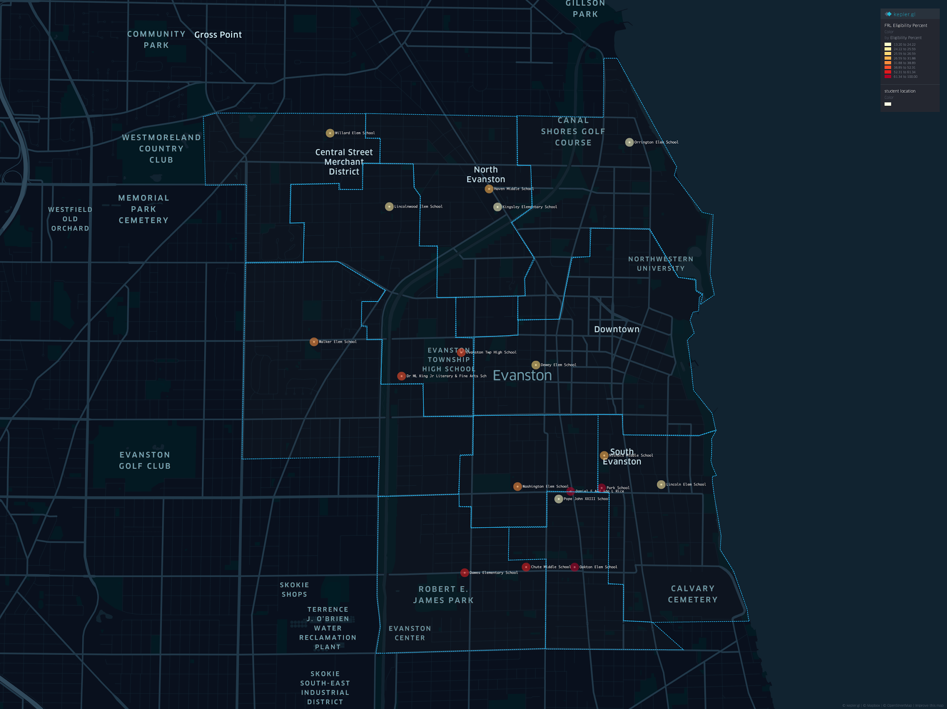

## **2.3 Chatbot**

Besides the interactive maps, a chatbot tool has been developed in Azure QnAmaker so that our neighbors in need can receive recommendations based on their needs. It follows a simple decision tree structure. Users can easily start the chatbot service by typing “Hi” in the text box. Then there will be a set of questions asked:

* Information about SNAP application
* Preference for grocery items or prepared meals
* Identification of need and priority for delivery

One question will be asked at a time with options that users can click on. Eventually there will be an information box that shows all the details on the food providers that best match with users’ needs.

Right now, English is the only language supported in chatbot service, but more languages can be easily added to meet the requirements. One potential functionality to be added in the future is the “alert” function which allows service providers to contact each other if they have extra resources to share.

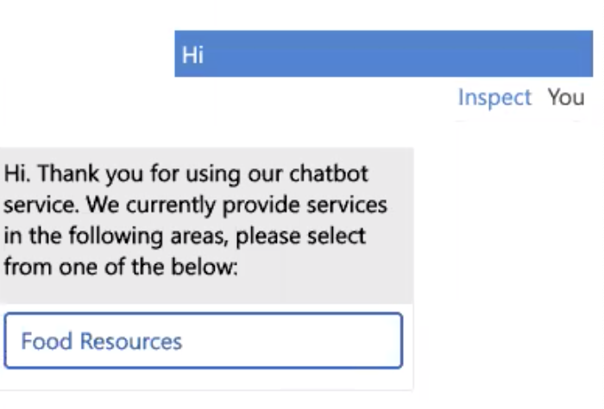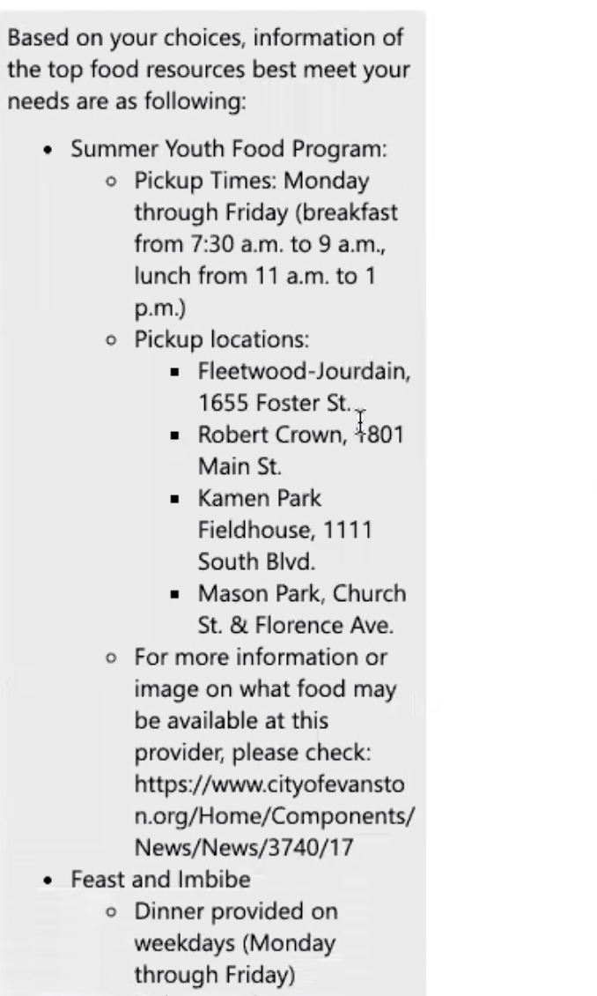

## **2.4 Producemobile: A Mini-Case Study**

We would like to share a brief spotlight on the Evanston Producemobile operation. This is an excellent example of how data mindfulness can lead to effective community responses to food insecurity. We would like to thank Rita Bailey, Shawn Iles for cooperating with us during our summer project.

### **2.4.1 Organization Description**

Producemobile is a collaboration by the Interfaith Action Committee of Evanston and the Greater Chicago Food Depository. It operates two locations in Evanston. The food truck is provided by the GCFD, while the volunteers are provided by Interfaith Action Committee. The frequency of operation is on the second Tuesday of each month. On offer are fresh fruits & vegetables, a selection of meats, among other produce.

### **2.4.2 Data Collection & Management Best Practices**

At each Producemobile operation, there is a rigorous and disciplined approach to Data Management. For instance, the following variables are conscientiously recorded at each distribution:

* **Site Name**: The location where distribution occurred
* **Date:** The date of the distribution
* **Inside/outside distribution:** Whether the distribution was indoors or outdoors
* **Amount of Produce Received:** How many lbs of produce were received from the GCFD?
* **Number of guests signed in:** How many guests were signed in?
* **Total Individuals Served:** How many individuals were served?
* **Truck Arrival time:** What time the truck from GCFD arrived?
* **Number of volunteers:** How many volunteers were present from the IAC?
* **Leftover Pickups:** Which organization picked up the leftovers?
* **Number of boxes for pickup:** How many excess boxes were picked up at the end of distribution?
* **Number of boxes of waste:** How many boxes are thrown into waste due to not being picked up?
* **Miscellaneous comments:** Anything that stood out at this distribution to take into account next time [free form text]

### **2.4.3 The Operational Problem & Present Solution**

The key problem faced by Producemobile was a planning one: **“How to plan how much food to bring to a given distribution location to minimize excess and shortages?”** This requires prior knowledge about how many individuals will show up to a particular Producemobile food distribution. This is a classic problem faced by many retailers.

To address this problem, a Shawn Iles, a veteran volunteer in charge of the operation, essentially uses a combination of guesswork and intuition built over a long time working at the site location. However, Shawn recognizes that there are numerous inefficiencies to this:

* For one, the operation is highly dependent on him and his intuition.
* Secondly, various trends that are beyond human detection are left unexplored.
  + This is especially problematic in the volatile COVID-19 era.

### **2.4.4 A Potential Data-Driven Solution**

One of the big advantages of Producemobile is the wealth of data it collects about each distribution from 2016 to present. From a data management perspective, the following two characteristics followed by Producemobile are key:

* Consistently formatted and disciplined data collection at each distribution event
* Data storage in an easily accessible location (For Producemobile, this took the form of simple Excel sheets)

With marginal effort, this allows a data driven solution to a classic business problem: **forecasting via a time series analysis**. Through simple time-series methods, we can detect things the following in the data:

* Trend over time
* Seasonal effects
* Latent cyclic behavior

Using this knowledge, forecasting the number of attendees at a particular Producemobile distribution becomes possible. This allows Producemobile to better serve its community by ensuring that shortages and excesses are avoided.

However, the real power of disciplined data collection and management lies beyond solely forecasting demand at a particular location: a virtuous cycle occurs that simultaneously improves Producemobile’s forecasting models and thus enhances Producemobiles ability to better serve its constituents. As data is collected each time, model parameters can be updated based on the divergence of their forecast from the actual number of attendees that arrived at that distribution. Over time, the forecasting model becomes stronger and so does Producemobile’s ability to meet demand at its location. Such a scientifically sound approach also makes Producemobile’s case stronger when requesting food from GCFD or funding from other agencies. The approach can also be applied to other aspects of Producemobile’s operations such as requisitioning volunteers, etc.

### **2.4.5 Forecasting in Action**

To illustrate the actionability of the above recommendation, our team at Everybody Eats built a time-series based forecasting model. The data we used consisted of 12 measurements (one per month) for each year from 2016 - August 2020. The model used was a Holt-Winters model. Seasonal decomposition and linear interpolation was used to impute null values.

We analyzed the following three key aspects of Producemobile’s operations:

* ***Number of individuals served at each distribution***
* ***Amount of food received from GCFD for each distribution***
* ***Number of volunteers expected to arrive at each distribution***

Here are some of our key insights:

* For number of individuals served at each distribution:
  + Tends to peak during: **March, May, September, November**
  + Tends to fall during: **January, February, April, October, December**
* For the amount of food received from GCFD for each distribution:
  + Tends to peak during: **January, March, May, July, September, Novembe**r
  + Tends to fall during: **February, April, June, October, December**
* For the number of volunteers at each distribution:
  + Tends to peak during: **January, February, March, April, September, November**
  + Tends to fall during: **May, June, July, August, October, December**

The following are the **predictions for the above three metrics till the end of the year**:

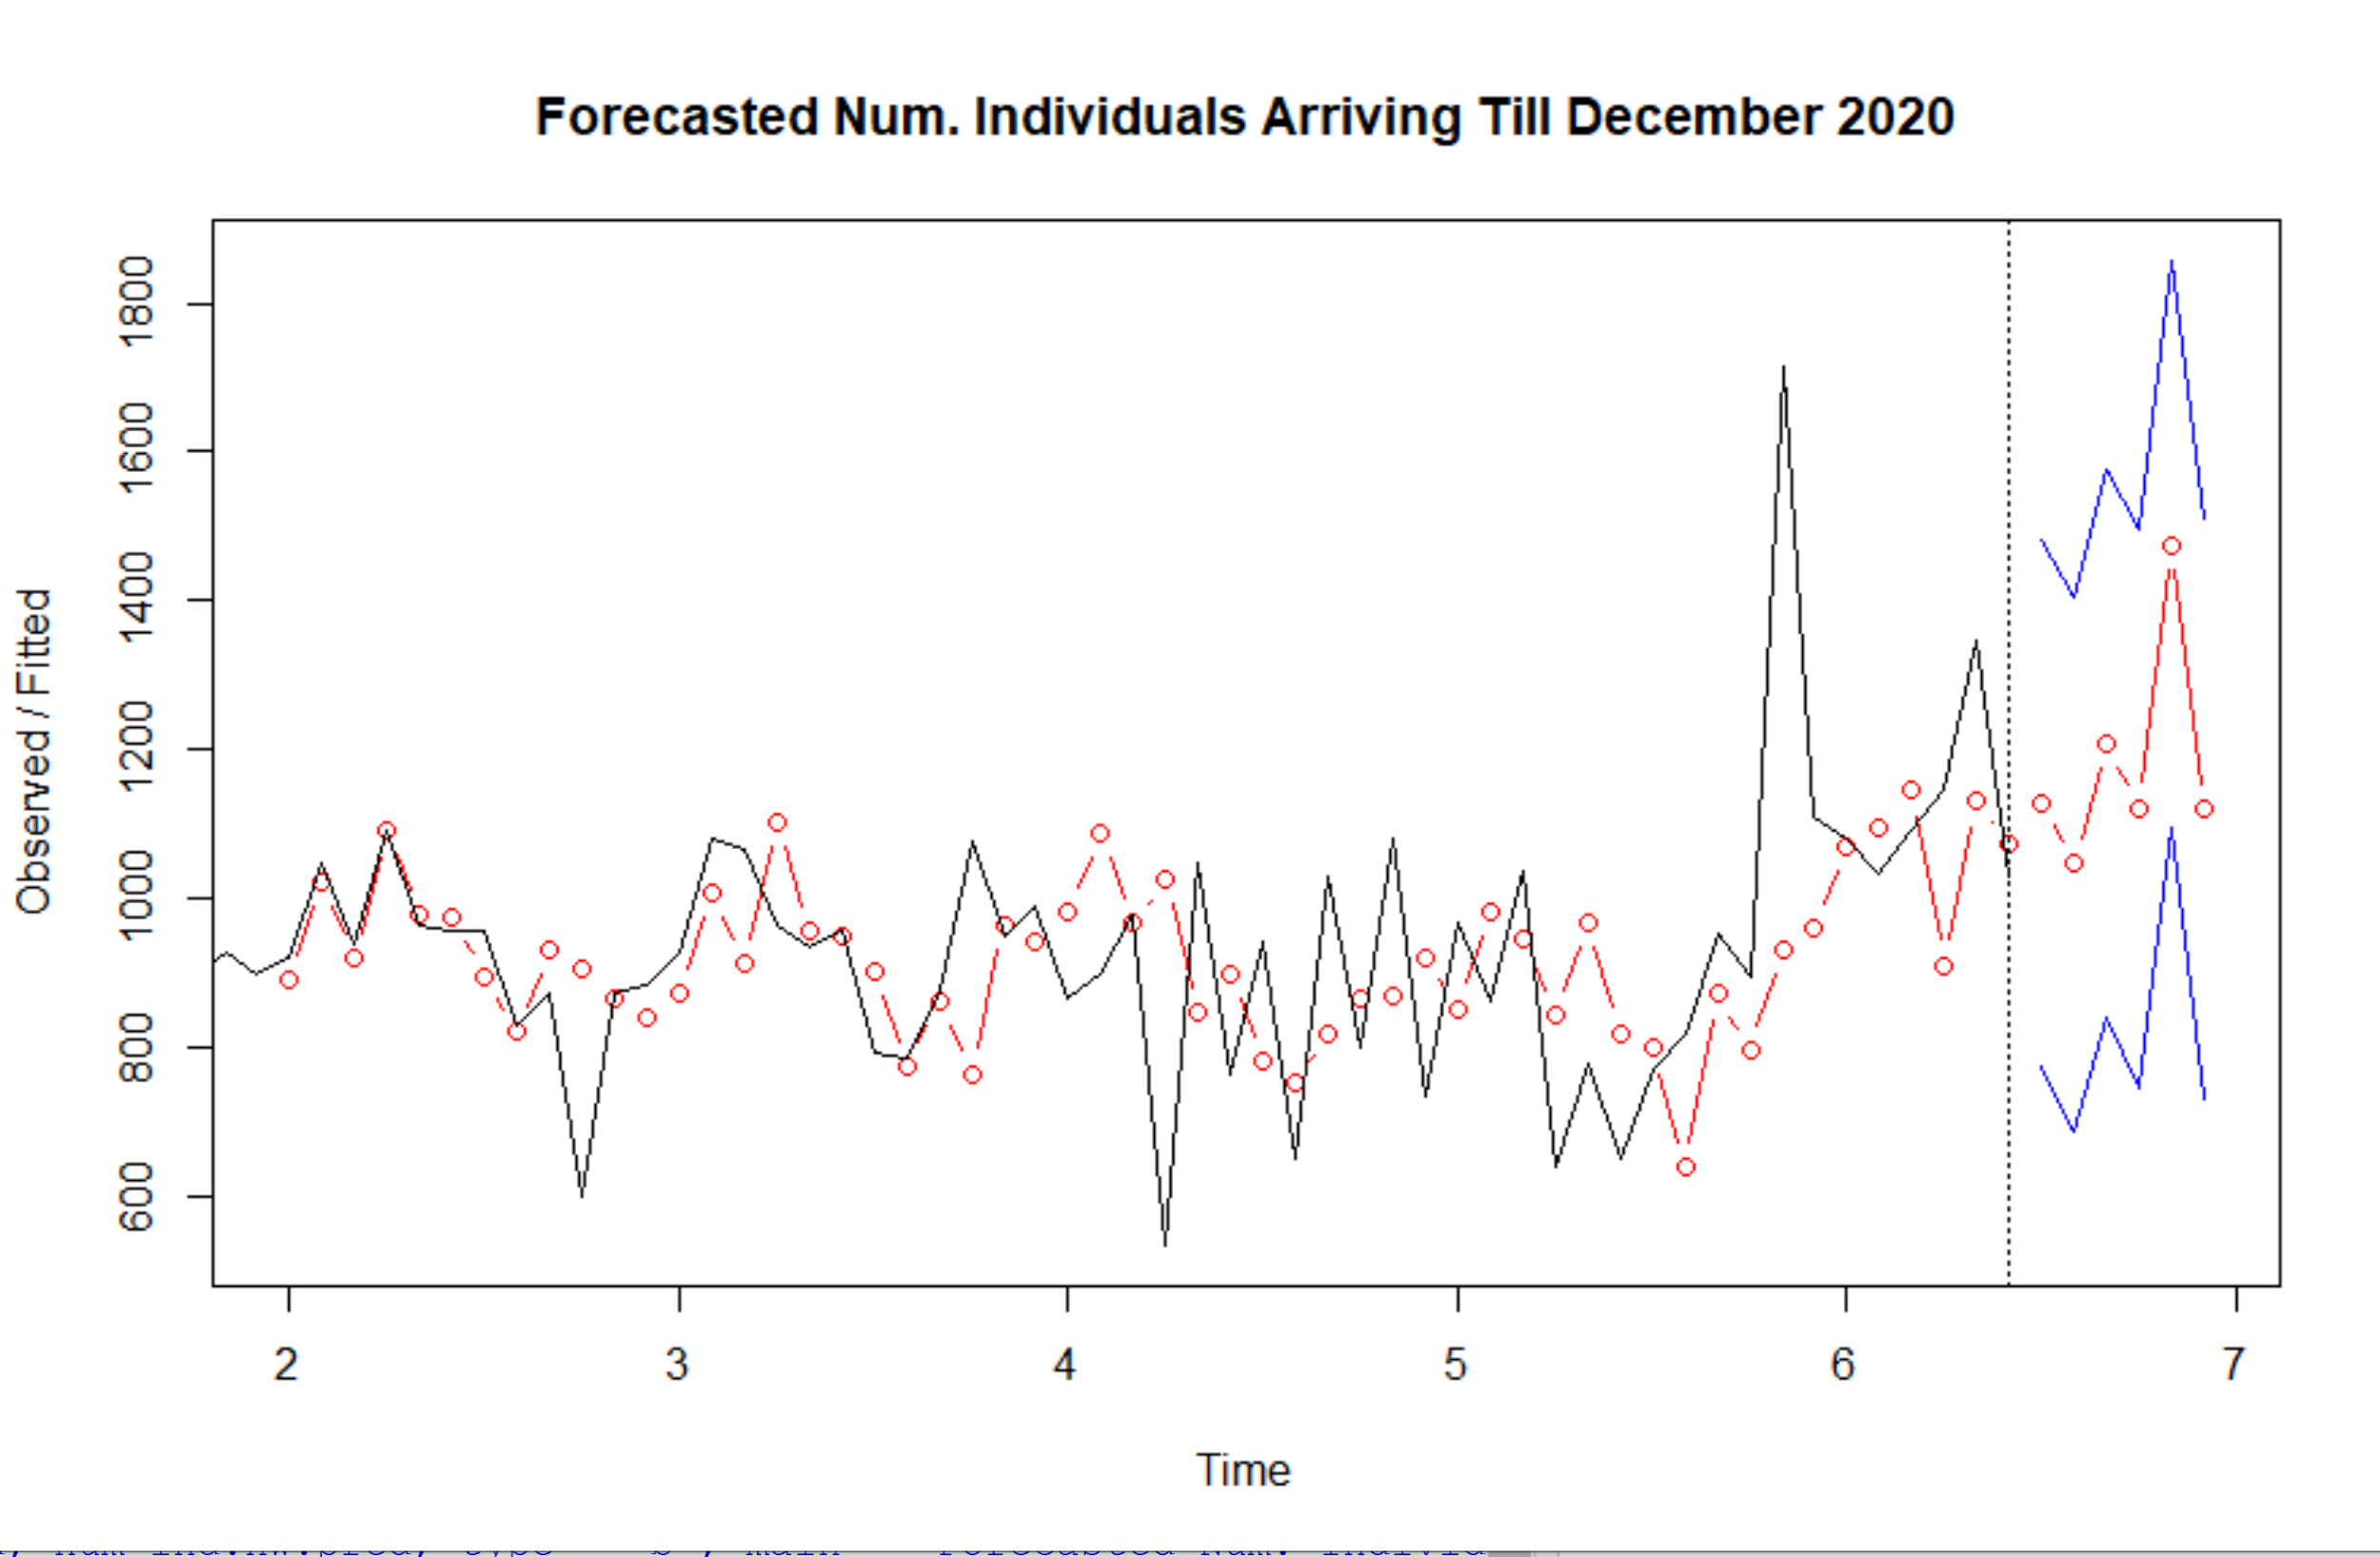

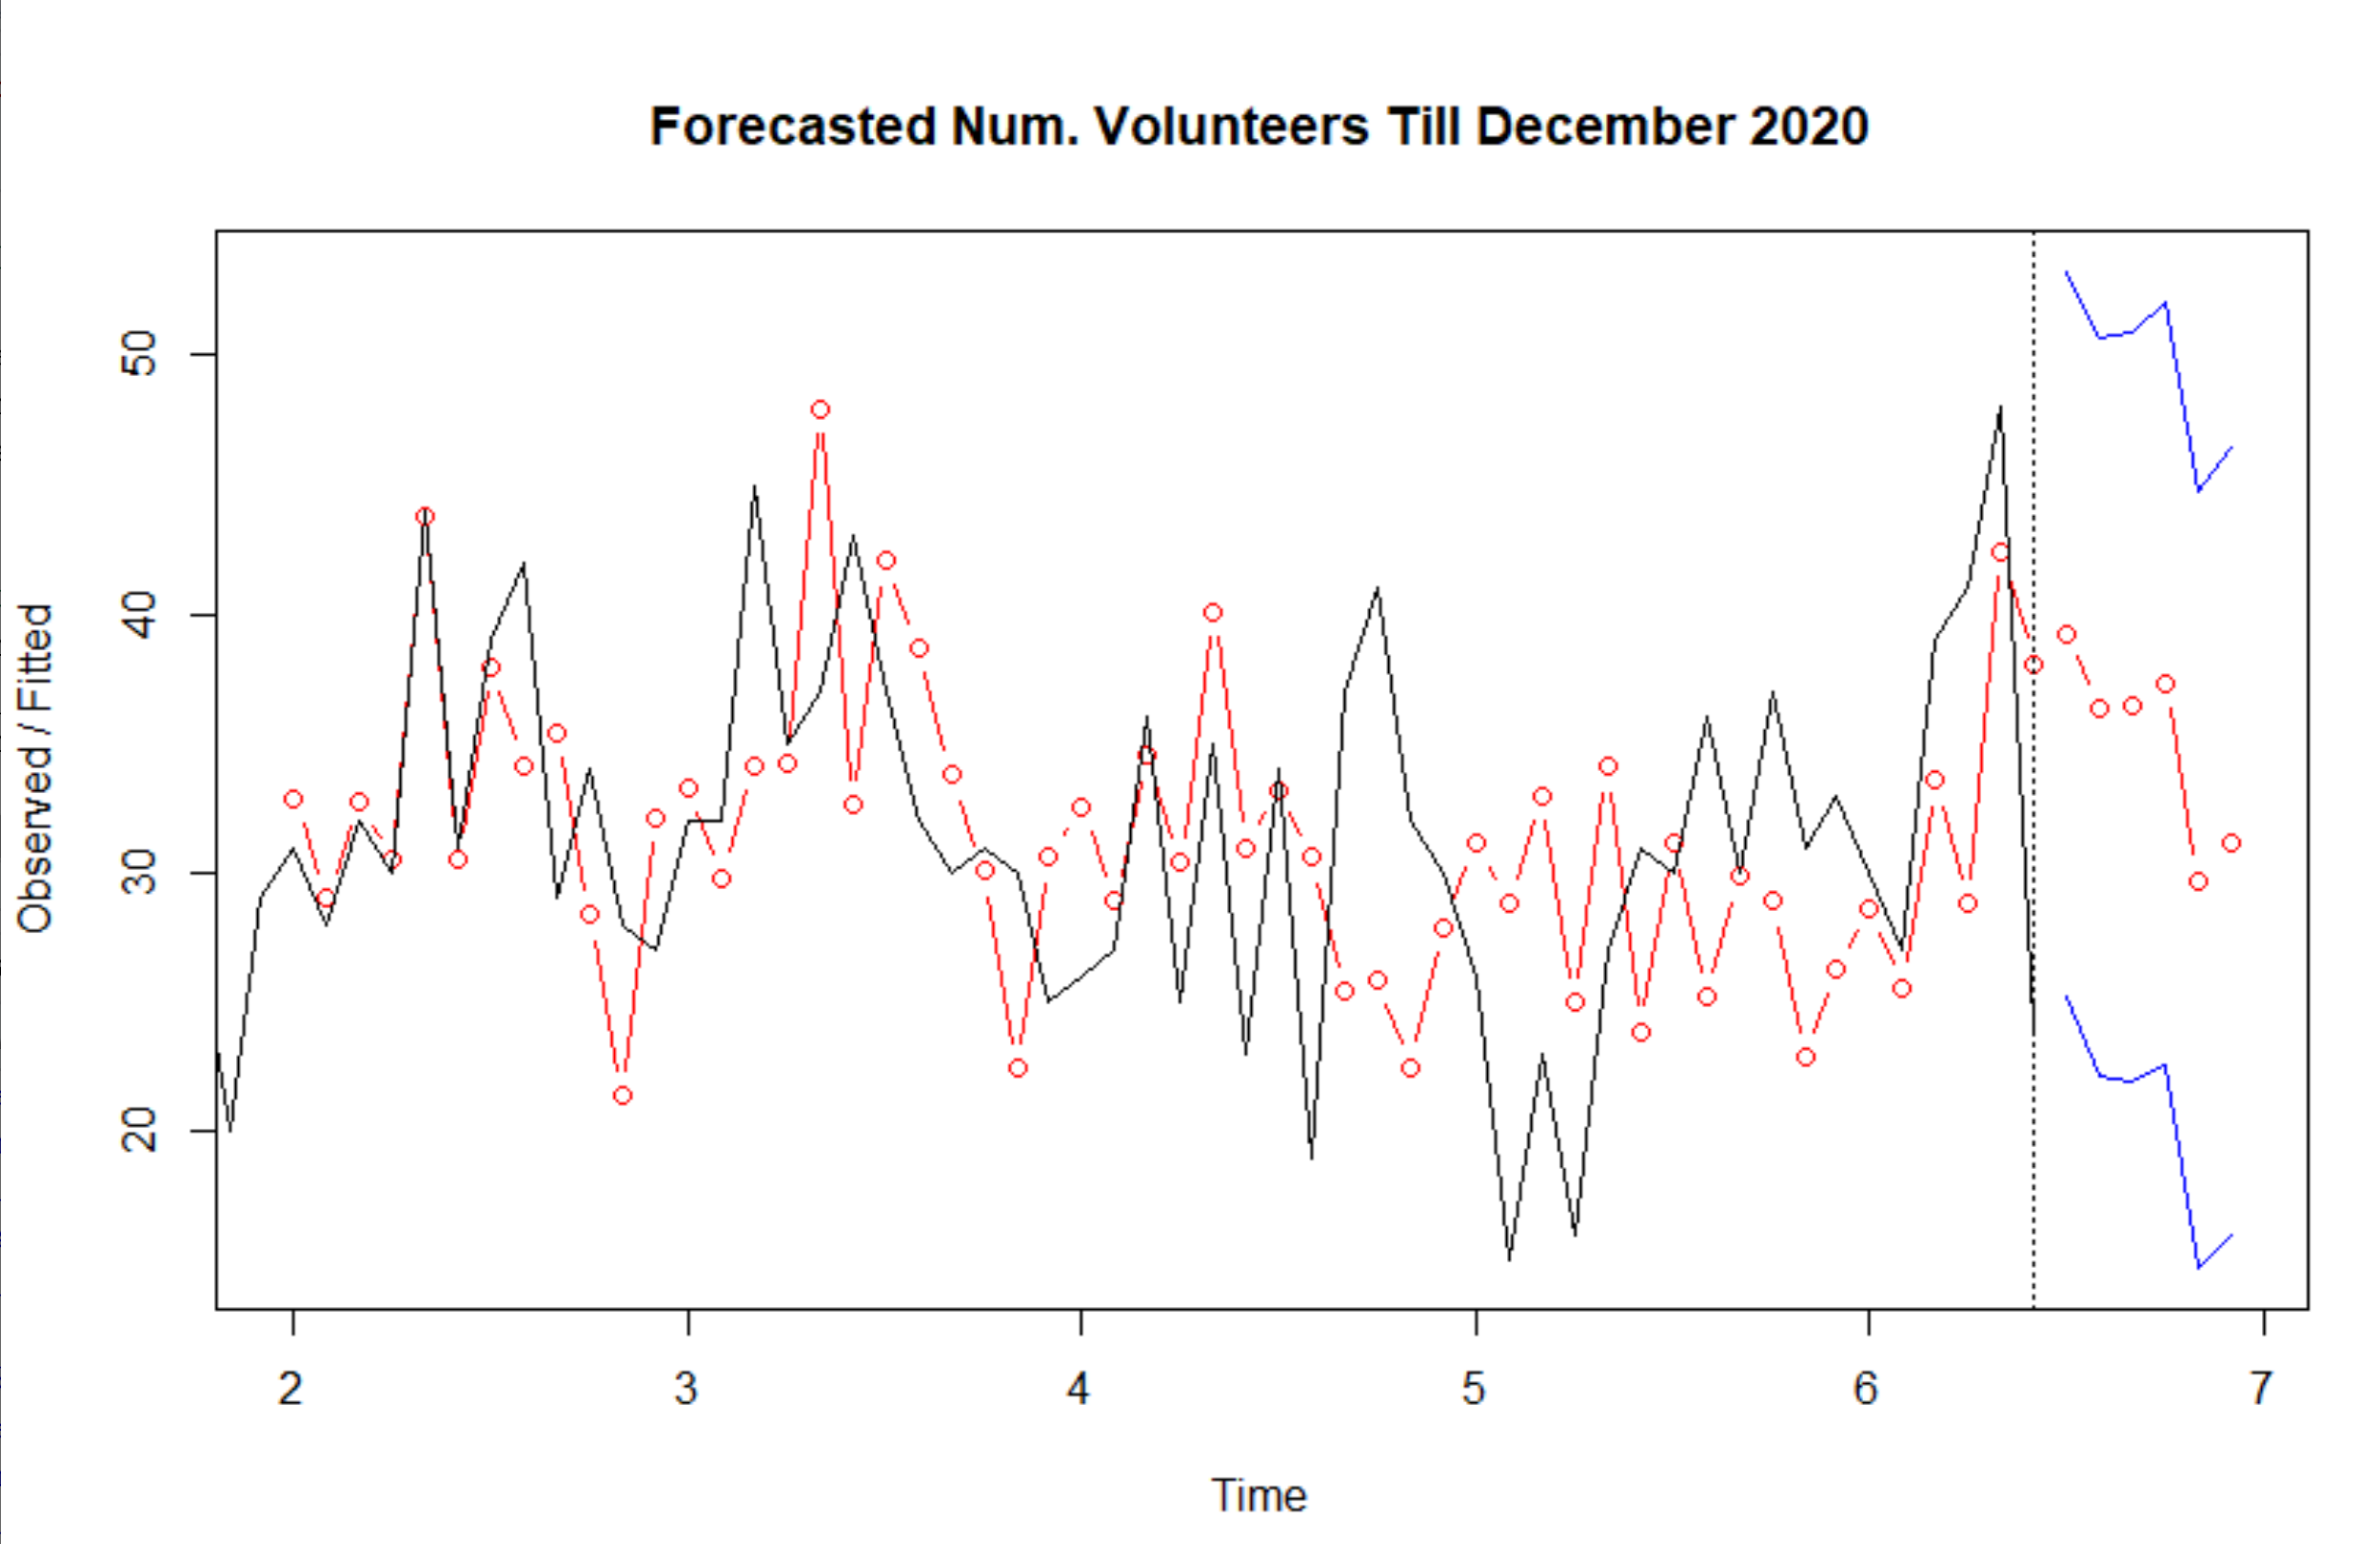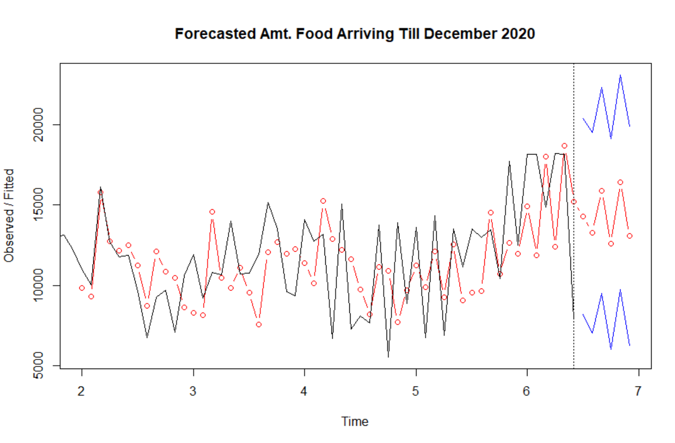

Some **Key Takeaways** from the above forecasts:

* The number of individuals is expected to rise till the end of 2020 (December)
* The amount of food received from GCFD is expected to stay level till the end of 2020
* The number of volunteers attending is expected to fall till the end of 2020.

**The key implication of the above is that there is a shortage of volunteers expected that coincides with an increase in the number of individuals attending Producemobile’s distributions, and a concurrent levelling of food arriving from GCFD.**

Finally, we can have a look at the decomposition of the three time series from 2016 to present (August 2020). This allows us to get a sense of the trend, and the seasonality of the time series.

1. **Number of Individuals Arriving at distributions from 2016-August 2020**

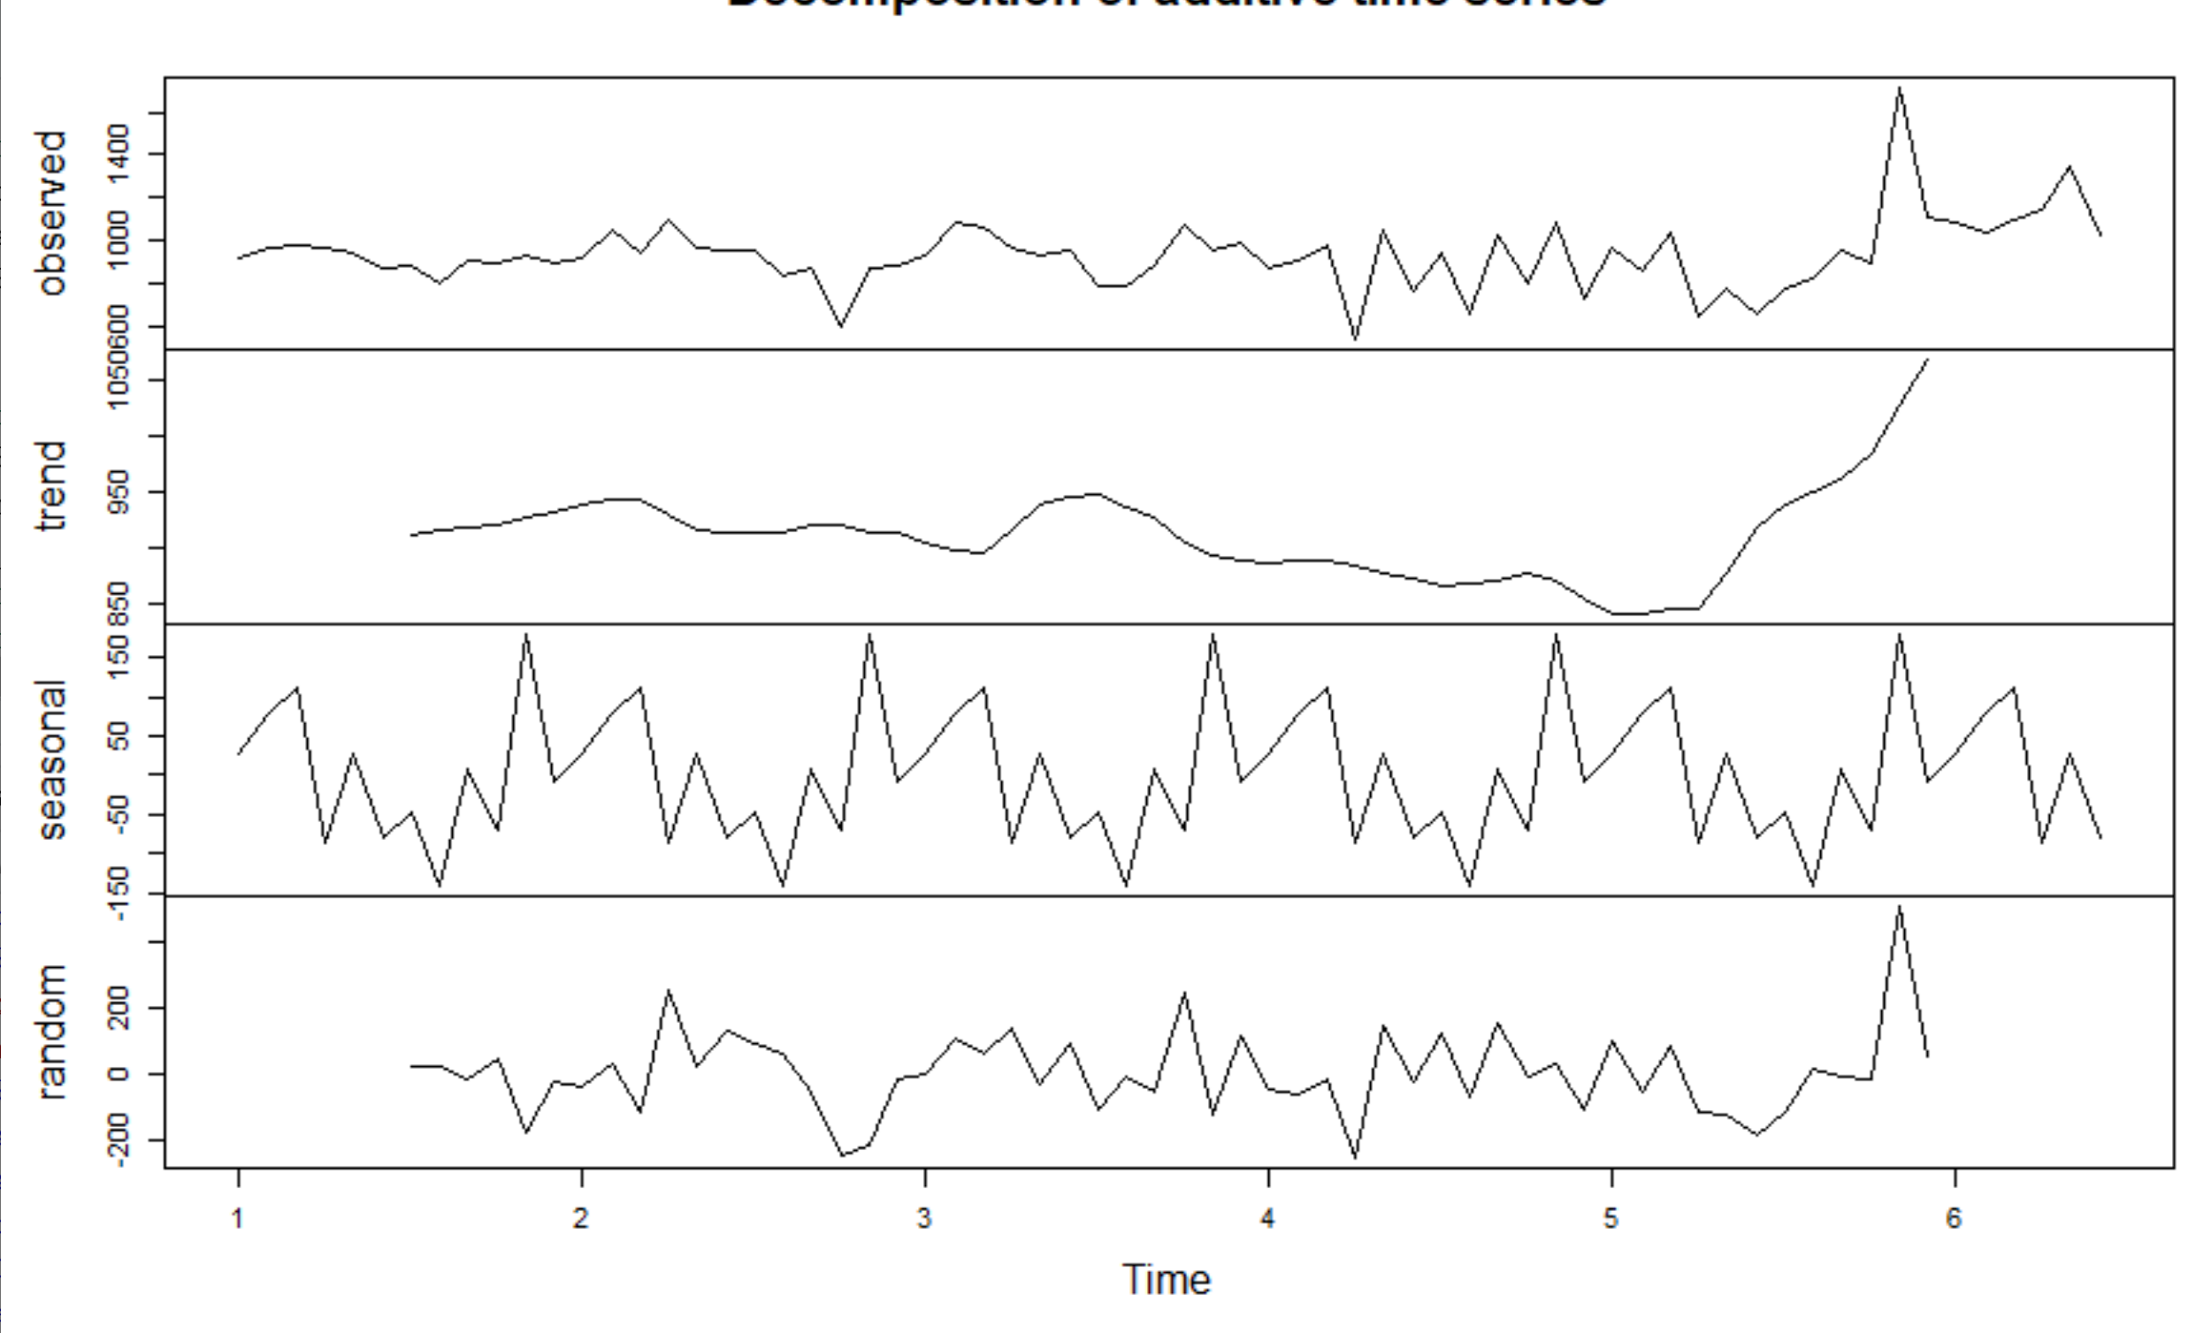

1. **Amount of food received from GCFD at each distribution from 2016 - August 2020**

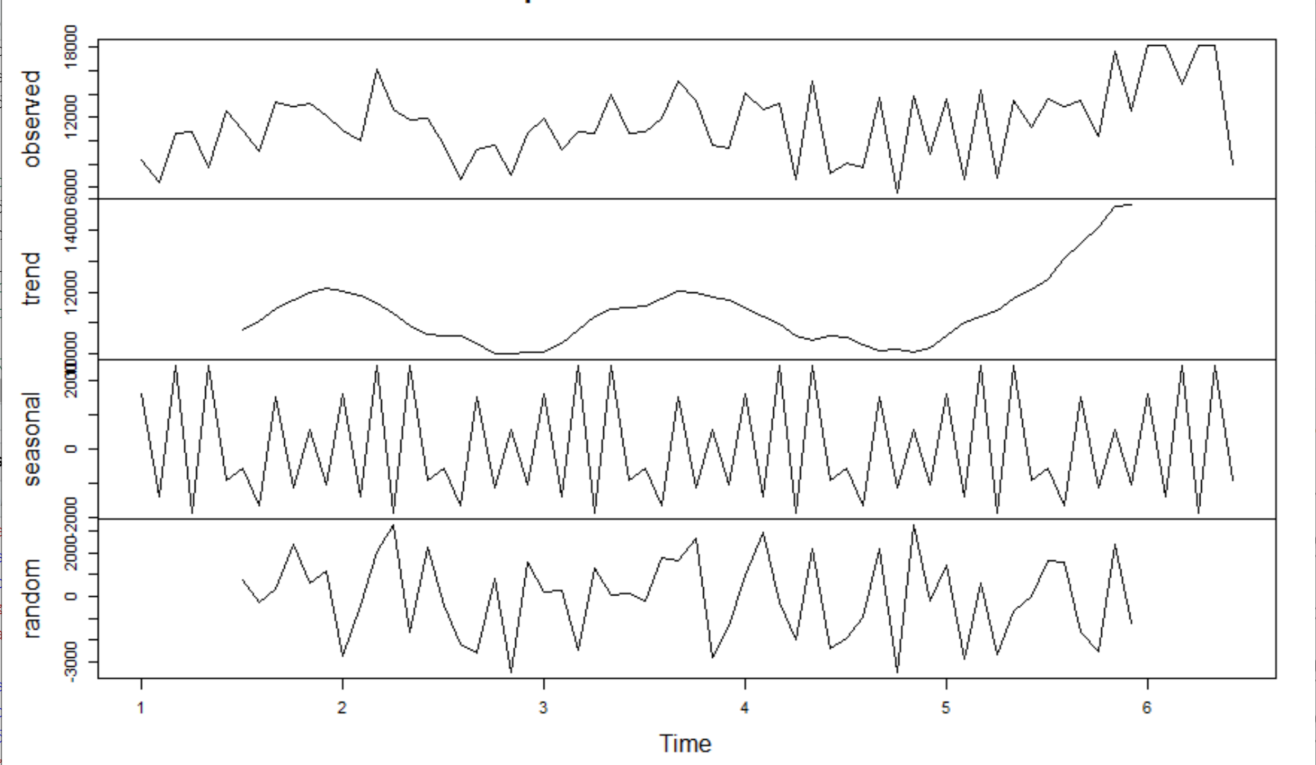

1. **Number of volunteers attending at each distribution from 2016 - August 2020**

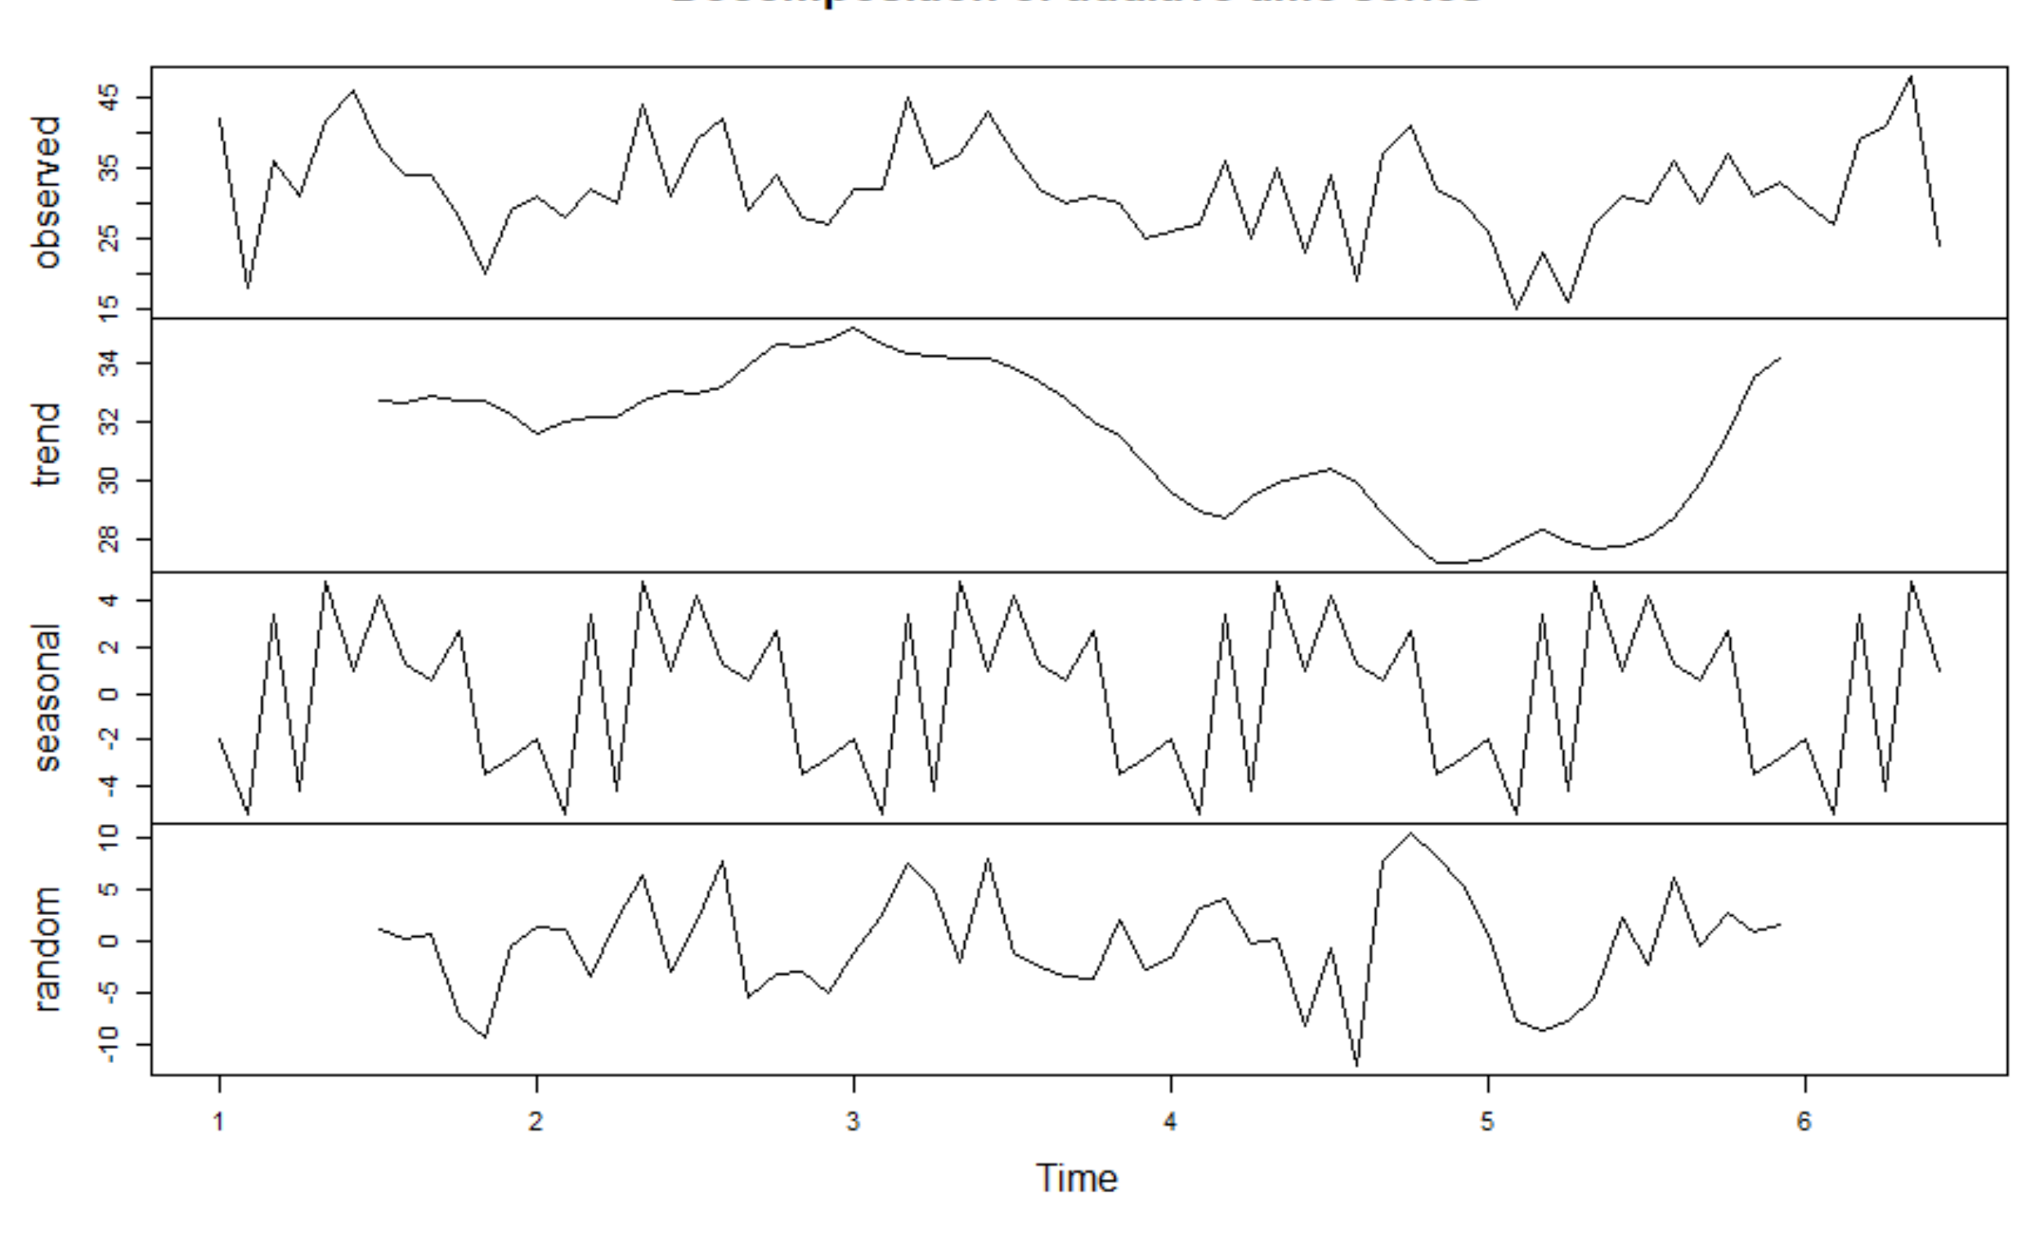

# **3 Conclusions**

By using data analytics tools, we looked into the underlying factors that might determine the structural food insecurity or lead to higher risks of food insecurity during the pandemic in Evanston. We also created prototypes for the toolkit that would be applicable and helpful in delivering better food assistance to our food insecure neighbors. With the constraints of limited available public data, we set examples of how organizations can apply the analytics and make more informed decisions. In the next section, based on the challenges we observed in this project, we’ll talk about our recommendations on potential improvements in data collection and management.

# **4 Potential Improvements & Further Steps**

## **4.1 Food insecurity survey for Evanston residents**

One of the major obstacles in this project was to collect data that can help us understand the food insecurity situation in a dynamic and granular way. As we already mentioned, most of the public and reliable data are either updated very infrequently, such as the US Census, or collected not as granular as ZIP Codes or Census Tracts, such as the COVID Impact Survey. Data collected on a regular basis at granular levels is helpful for the city and organizations to understand the food insecurity in Evanston in a dynamic way, which is key to providing more efficient and prompt food assistance to our food insecurity neighbors. In order to achieve this goal, we suggest the city to conduct a food insecurity survey among Evanson residents. When designing the survey, we referred to the questions in the COVID Impact Survey and added the questions that we thought would be useful in the study of food insecurity in Evanston. Through the data collection and analysis, we hope the city can better understand the food insecure community, predict the future needs more accurately and get fully prepared. (<https://northwestern.app.box.com/file/715227014026>)

## **4.2 Distribution cost survey for food pantries and organizations**

During one of our meetings with the task force, we learned that it is important for the city to figure out how much funding should be allocated to each family. Therefore, we designed a cost analysis survey (<https://docs.google.com/forms/d/e/1FAIpQLSepGLQNeDrsqhIufTqm1swOdU04HwJm6PRVLdd8_rXtCFFhaA/viewform>) for food pantries and organizations. The goal of this survey was to help the city understand the distribution cost at each food provider and make more data-driven decisions when deciding the fundings.

## **4.3 Recommendations for data management**

When we were collecting data from different organizations, we learned that food pantries and the City of Evanston do not collect demographic or geographical information about the community in food insecurity, and organizations do not work collaboratively on food distributions, which made it difficult for the city and organizations get informed of the fast-changing situation during this pandemic and how they should deliver the assistance in response to the increasing food insecurity. We understand that organizations are reluctant to collect too much personal and sensitive information from the community in food insecurity, and different organizations work in their own ways, but we think that collecting information from our food insecure neighbors and building a connected and shared database among food providers are the key to better serve the community. Therefore, we listed some of our recommendations for data management for the city and organizations, in order to facilitate a more comprehensive view of the food insecurity and a collective food assistance network in Evanston.

(<https://northwestern.app.box.com/file/692115913099>)

# 

# **References**

*Abigail Wozniak, Joe Willey, Jennifer Benz, and Nick Hart. COVID Impact Survey: Version # [dataset]. Chicago, IL: National Opinion Research Center, 2020.*

*Economic Research Service (ERS), U.S. Department of Agriculture (USDA). Food Access Research Atlas,* [*https://www.ers.usda.gov/data-products/food-access-research-atlas/*](https://www.ers.usda.gov/data-products/food-access-research-atlas/)

*PolicyMap.* [*https://www.policymap.com/maps*](https://www.policymap.com/maps)

*Schanzenbach, D. W., & A. Pitts. 2020. Estimates of food insecurity during the COVID-19 crisis: Results from the COVID Impact Survey, Week 1 (April 20–26, 2020). Institute for Policy Research Rapid Research Report.* [*https://www.ipr.northwestern.edu/news/2020/food-insecurity-triples-for-families-during-covid.html*](https://www.ipr.northwestern.edu/news/2020/food-insecurity-triples-for-families-during-covid.html)